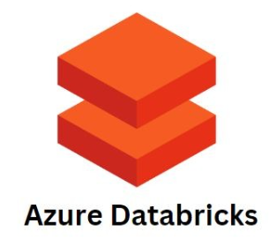



**PART - 1**

Contents

Coverage 3

Data Import to Databricks Workspace 4

Data Engineering 7

Reference Architectures – Modern Data Engineering 8

Lakehouse Medallion Architecture 8

Apache Spark 9

Databricks Platform 12

Azure Account 14

Azure Portal Overview 19

Databricks Workspace 26

Azure Modern Analytics Architecture 52

Medallion Architecture 52

Databricks Documentation 52

Databricks Platform Architecture 53

Azure Databricks Cluster 56

Databricks Utilities 81

Working with the Databricks File System 90

Mounting ADLS to DBFS 98

Databricks Cloud 127

Databricks Unity Catalog 127

Setup Unity Catalog 130

Unity Catalog User Provisioning 146

Working with Securable Objects 158

<https://tsys.udemy.com/course/master-azure-databricks-for-data-engineers/learn/lecture/41719048#overview>

<https://tsys.udemy.com/course-dashboard-redirect/?course_id=5733038>

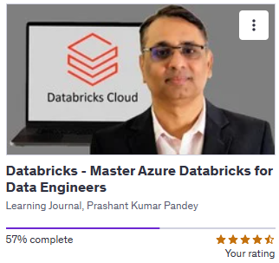

## Coverage

We basically aim to learn Databricks Cloud Platform, how to use Databricks Cloud Platform and its capabilities to build Lakehouse Solutions, or Lakehouse platform.

﻿

1. Databricks in Azure Cloud
2. Working with DBFS and Mounting Storage
3. Unity Catalog - Configuring and Working
4. Unity Catalog - User Provisioning and Security
5. Working with Delta Lake and Delta Tables
6. Manual and Automatic Schema Evolution
7. Incremental Ingestion into Lakehouse
8. Databricks Autoloader
9. Delta Live Tables and DLT Pipelines
10. Databricks Repos and Databricks Workflow
11. Databricks Rest API and CLI
12. Bonus Capstone Project
    1. Designing and Implementing Lakehouse
    2. Designing end-to-end Solution
    3. Implementing Automation testing
    4. Azure DevOps for implementing CI/CD

Delta Lake and Delta tables are one of the core features of Databricks Platform. Databricks platform integrates Delta Lake and offers delta tables.

We will be learning about Delta Lake, its capabilities, its features, all the Delta Lake tools and optimization techniques, along with the Delta tables and how to use Delta tables in your project. We will also go through schema evolution. In this course, we will try to learn how to handle manual schema evolution, or how do you implement automatic schema evolution with different tools like Delta Lake or during the data ingestion and all that. I will also help you understand incremental ingestion into the Lake House platform.

We will not go into the details of learning any data ingestion tool, but we will learn it from the architecture point of view that how do you architect your lake house solution, for ingesting data from sources into your lake house platform and Databricks? What other tools and capabilities Databricks as a platform has to offer for incremental data ingestion? How do we manage schema evolution during the data ingestion? What are the different tools? What is the preferred tool?

Along with that you will also learn Databricks Auto Loader, how to use Databricks Auto Loader. What it is you will learn that we will go into Delta live tables and Delta pipelines. Delta live tables and Delta pipelines are, declarative ETL tool or declarative ETL offering of the Databricks platform. So we will go into the details of Delta pipelines and learn what is DLT. You will also learn about Databricks repos so you can integrate your source code, or source control with the Databricks platform and work through the source control.

So you will learn Databricks repos. You will also learn Databricks workflows so you can orchestrate your job, create job dependencies, and build your pipelines using Databricks workflow. We will also learn Databricks Rest API and CLI, so you understand how project related automation activities can be performed using Rest APIs and CLI. And in the end, we have a bonus capstone project which starts with the basic requirement. We discuss what is the requirement, and then I will walk you through every step of translating a requirement into a solution design, and then taking various design decisions, and then finally implementing the Lake House project using that requirement.

The idea behind the capstone project is to help you understand and use whatever you learned during the course. Throughout the course, we will be learning different techniques and tools, but how all that knowledge can translate into solution design and solution implementation and implementing your lake house project. So that's the objective for the capstone project, which will bind all your learning together at one place in the form of a project, and you will learn how to implement Lake House project using Medallion Architecture. Along with the project, you will also learn designing and implementing Lake House platform, designing an end to end solution, various decision making items. how you implement your testing strategy, how you automate your testing, and your lake house projects, how, you can implement your CI, CD pipeline.

So we will be using Azure DevOps because this course is focused on Azure, cloud platform. So we'll be using Azure DevOps to build our CI CD pipelines for the capstone project.

## Data Import to Databricks Workspace

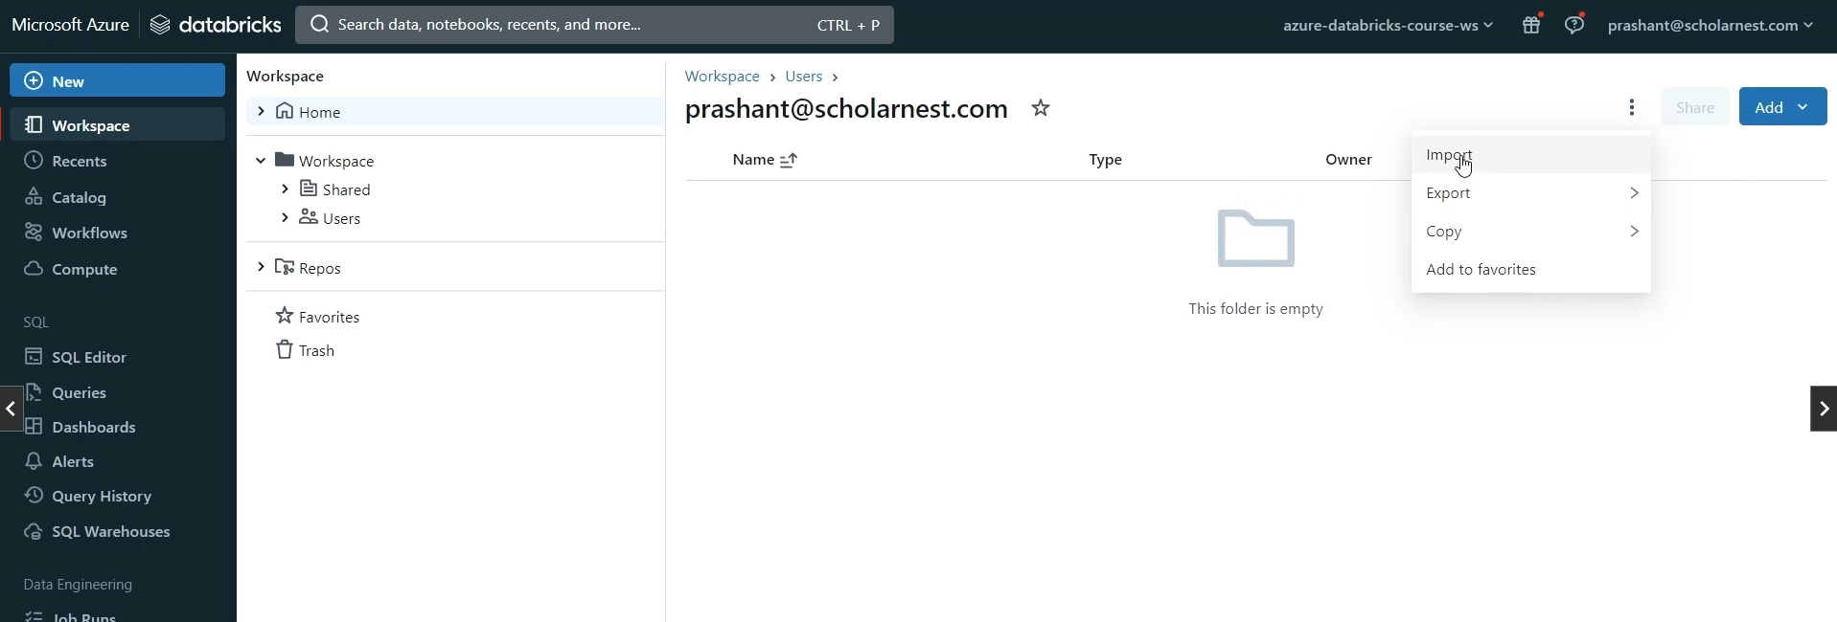

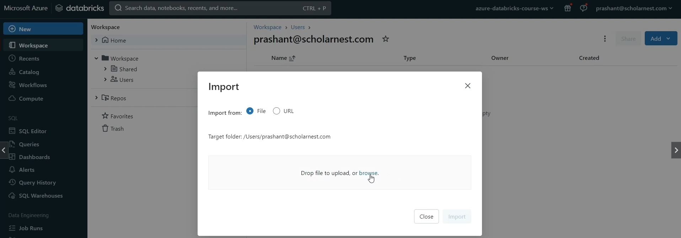

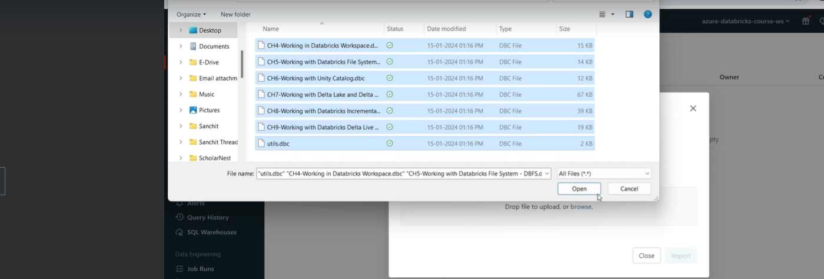

Hit the import button and import them.

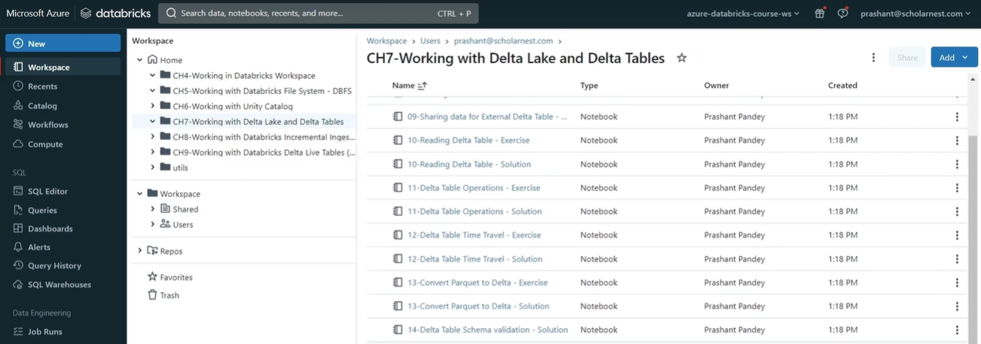

There are two copies of each notebook – exercise notebook and solution notebook

Exercise Notebook

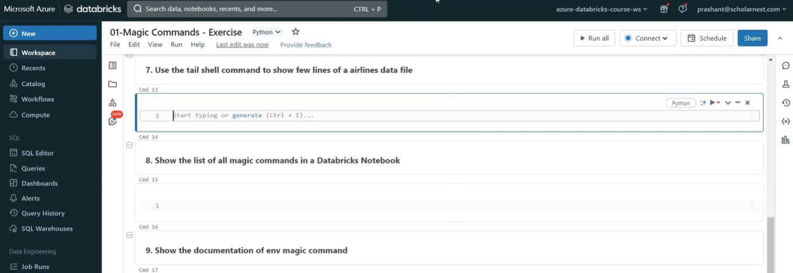

Solution Notebook ( all the cells are filled here )

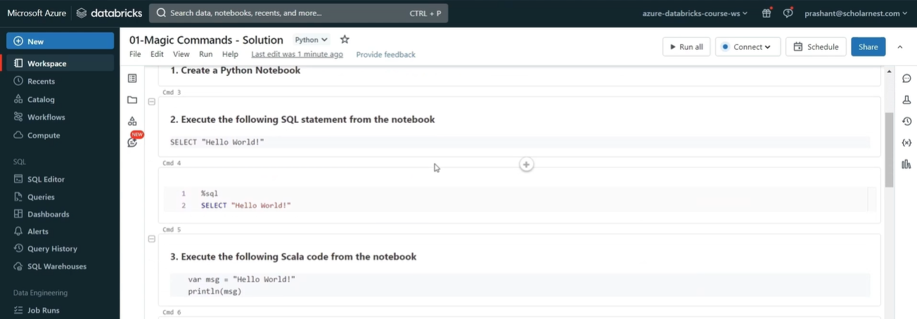

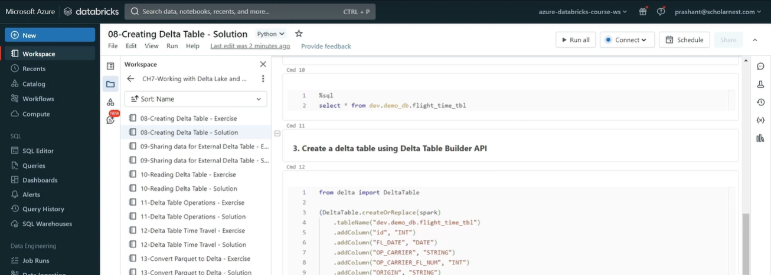

There is also Sample Data to be imported later.

Go to Azure Portal and create a storage account. Go to the containers and you would be asked to create a container there

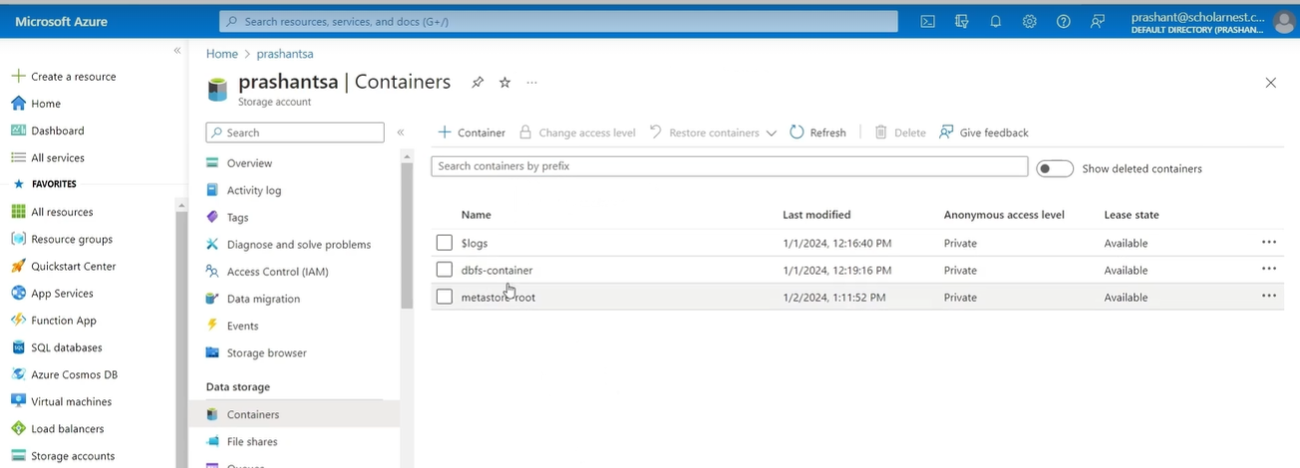

We create the dbfs-container.

Upload sample data files in this container

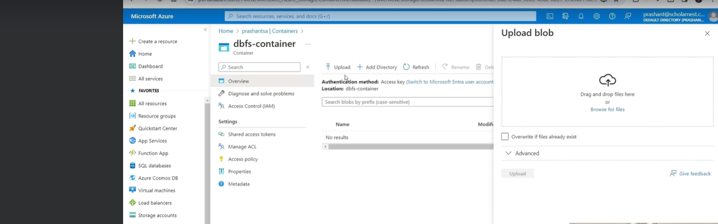

Drag the files to the Drag and drop section to the right and upload it

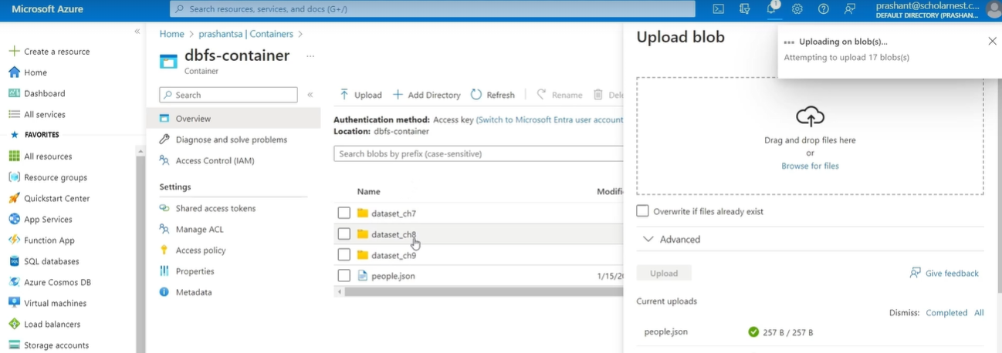

## Data Engineering

The people who interact with the Enterprise Data are as below

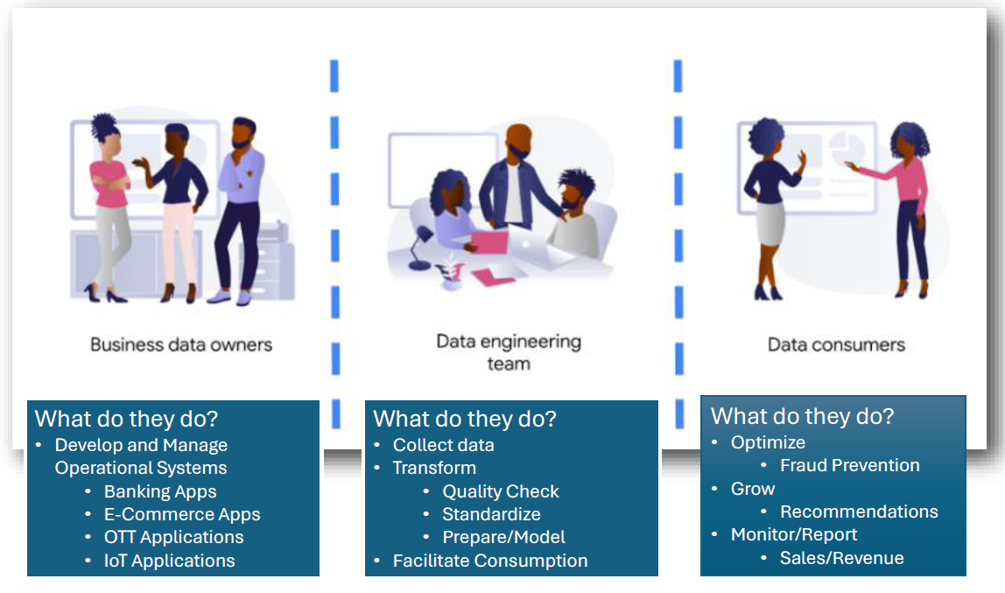

Business Data Owners capture and save customer data through there customer facing applications – from the customers.

Data consumers are responsible for optimizing and grow the business. Also responsible for monitoring and generating reports for tracking different KPIs. Fraud Prevention is a business optimization solution. Monitor Sales and Revenue.

Data Engineering team collects and transforms the data for consumption of the Data Consumers. The Data consumers are the customers for the Data Engineering team. They get requirements from the Data consumers team and then work backwards on from where the data can be collection, and then prepare the data ( transform ) and facilitate consumption of that data to data consumers.

If we try to categorize or classify data engineering projects then we can easily do it as following:

1. Data Integration/ Data Ingestion
2. Data Engineering/ Processing
3. Analytical Stores/ Data Marks
4. Reporting Analytics

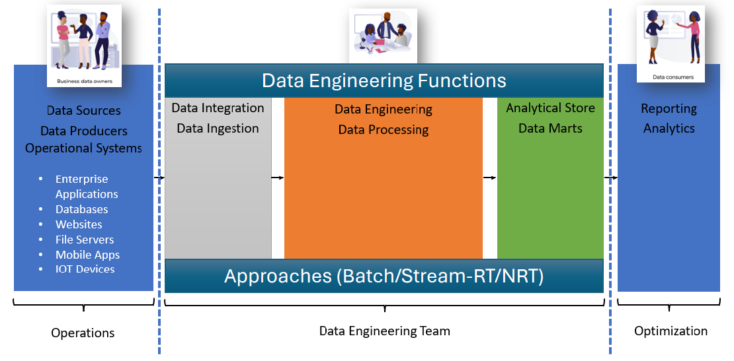

Approaches could be Batch based or Stream ( Real-time/ Near Real-time )

Operations – Enterprise Apps, Databases, Websites, File Servers, Mobile Apps, IOT Devices

Optimization – Reporting Analytics

## Reference Architectures – Modern Data Engineering

### Lakehouse Medallion Architecture

This is the reference architecture for a typical data engineering project, or for a modern data engineering project? This is also known as **Lakehouse Medallion Architecture**

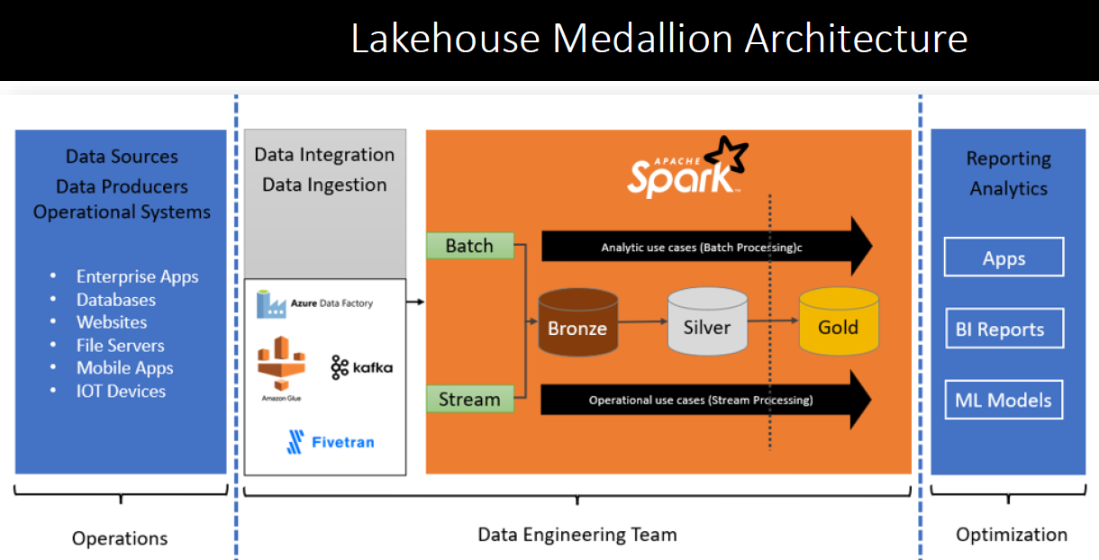

The first function of the data engineering project is data ingestion data collection or data integration. The architecture diagram represents that to the left side in the gray box. First thing we do data ingestion or data integration. And for that we might want to use some specialized tool that are best according to our source system. So we choose tools to ingest and collect data.

The data ingestion could be done using the batch data collection approach or streaming approach. In batch data collection approach, we collect data at regular intervals, maybe daily, maybe hourly, maybe every 30 minutes.

In streaming. In data ingestion approach, we collect data as quickly as possible as it is being produced at the source system. So we collect data continuously. So the architecture supports both type of approaches batch approach and streaming approach. So we collect data either in batch mode or in streaming mode or mix of both. Some part some data we can collect in batch mode. Some data we can collect in streaming mode. So up to here is our data ingestion or data integration. And after that the architecture recommends building rest of the system in layers.

The minimum number of layers are three. So the architecture represents three minimum layers for your data engineering project. First layer is known as bronze layer. The second layer is known as silver layer. The last layer is known as gold layer. So you should have minimum three layers. So bronze layer is supposed to store your raw ingested data as it is ingested.

And rest of the solution starts from the bronze layer. So we read data from the bronze layer. Do required processing transformations, data engineering activities, improved high quality data, all that we keep in a separate layer, we call it silver layer. And then the final work preparing data for consumption, filling your results into the desired data models is done in a separate layer. And this layer is known as gold layer. So the idea is you ingest data and keep implementing your solution step by step over these layers from bronze to silver to gold. And that's how the Lake House medallion architecture, recommends.

And these activities you can perform either in batch mode, you can do in near real time mode, or you can do it in real time streaming mode. All three approaches are, supported and can be implemented using this architecture. Now, the last question is how do we implement this lake house medallion architecture? What are the technologies involved there? What are the technology components?

## Apache Spark

Apache Spark is an engine for executing data engineering, stream processing, and machine learning on distributed clusters.

|  |  |
| --- | --- |
| **Capabilities**   * ANSI SQL * Batch Processing API * Stream Processing API * Graph Processing API * Machine Learning API | Who is using Apache Spark? Thousands of companies, including 80% of the Fortune 500, use Apache Spark.  If you try to understand the spark stack or the architecture. So at the bottom, Apache Spark is a framework which runs on a distributed cluster of computers. |



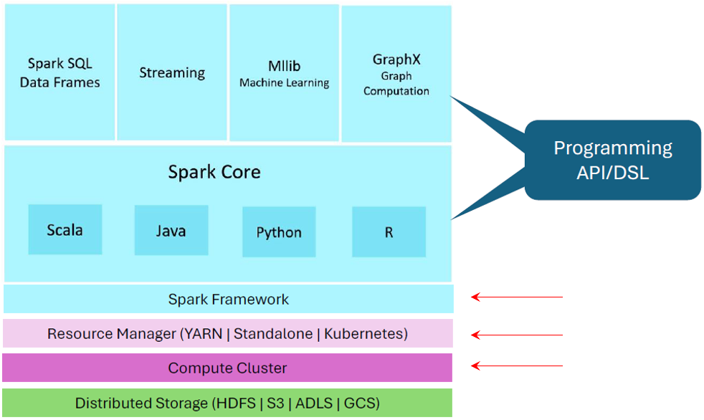

It it is a framework which runs on a cluster of computers. And for executing Apache Spark on a cluster of computers, we need some kind of cluster manager or cluster operating system, or simply called cluster resource manager. There are variety of resource managers supported by spark, including Yarn, standalone, Kubernetes, Mesos.

So Spark Framework runs on the cluster of computers using these resource manager and for reading or writing data. It's it's a data engine data processing engine, right. It allows us to do the data processing. So for reading and writing data in terms of storage, a spark can integrate with HDFs, S3, ADLs, Google Cloud storage, etc., a variety of distributed storage systems. So that's how, things are stacked for Spark Framework to work on top of the core Spark Framework, spark offers Spark Core APIs.

These are the APIs that we, as a data engineer or application developer can use those APIs. These are also known as spark RDD APIs.

These APIs are available in four languages like Scala, Java, Python, and R, but these are the core APIs not recommended for direct use.

And that's why spark has developed some more advanced and generalized and simplified APIs for data engineering or data processing activities.The most popular one are spark SQL and data frame APIs. Then we have Spark Structured streaming APIs, Mllib APIs, and graphics. So that's how the spark stack looks like.

**Why spark is so popular.**

Here are the reasons I spark offers you a great level of abstraction.

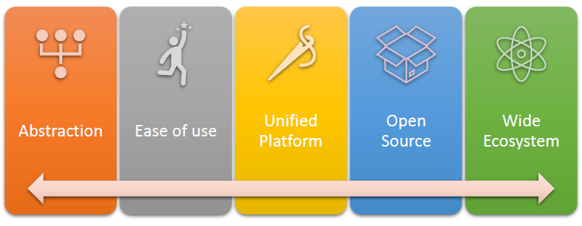

It hides all the complexities of distributed data processing. We simply write simple SQLs or data frame APIs without even realizing and knowing that data will be processed in parallel using the Distributed Data Processing engine, which is a spark framework on a cluster of computers. All those complexities are hidden from end users, or the developers or the data engineers.

That's the abstraction spark offers. It's easy to use.

You can use spark SQL, the simplest interface for developing spark applications. Or you can use different types of APIs available in different languages. It's a unified platform because a single platform offers you a variety of capabilities. You can do SQL, you can do data frame processing, batch processing, stream processing, machine learning, graph processing, all on a single unified spark platform. It's open source. That's the biggest advantage. And it also offers a wide ecosystem. So it since it is open source, a lot of companies collaborate in the open source project and they develop a lot of different kind of integration and capabilities with their tools. So a spark ecosystem has a wide ecosystem of integrations already available and developed so far. And that's why Apache Spark is super popular for data processing and especially big data engineering activities.

So we understand what is spark and why it is so popular.

**What Spark is not.**

Let's try to understand that there are many things that we need for developing an enterprise grade data engineering solution. And all those requirements are all those capabilities are not part of the Apache Spark, the open source Apache Spark. There are things that are missing. I have not listed all those, but here are five most critical things that you need in an enterprise grade data processing or data engineering applications, which are missing from Apache Spark.

|  |  |
| --- | --- |
|  | Apache spark doesn't come with the data storage infrastructure, right? It doesn't have its own storage layer. It always requires integrating with some other storage solution like HDFs or Amazon S3 or ADLs. So that's not part of the Apache Spark.  Apache spark doesn't come with the acid properties, acid transaction capabilities. Acid is atomicity, consistency, integrity and durability. This is one of the most critical and essential features of any data system. Apache Spark does not have its own capability to ensure Acid compliance. We can integrate some other solutions with spark to bring Acid capabilities to spark, but it's not part of the Apache Spark project. |

Apache spark doesn't come with a robust, centralized metadata catalog. It has its own small, simple catalog, but it doesn't come with a robust, proper centralized metadata catalog. So that's a missing feature from Apache Spark.

Apache spark doesn't come with the cluster management capabilities. We cannot create clusters. We cannot destroy clusters. We cannot manage clusters using Apache Spark. Apache spark doesn't have that capability. That's part of the cluster management system or, cluster resource manager. So that's missing from the Apache Spark in an enterprise grade application.

We typically want to automate a lot of things. Lot of things need to be automated. Apache spark does not offer a good set of automation APIs or SDKs or command line tools to implement lot of, project automation activities. So those things are missing.

So the point is simple, super straight. Apache spark is most popular data engineering especially big data engineering tool. But it's not complete in itself. It requires a lot of additional capabilities and features to be adopted for a good enterprise grade data engineering solution. And that's where a variety of spark platforms comes into play.

|  |  |
| --- | --- |
| Some of the popular platforms are listed here. | 1. At the top we have **Cloudera** **Hadoop** **platform**, which is a **Hadoop** **platform**, but spark runs on Hadoop also. So Cloudera Hadoop is the most popular on premise Hadoop platform, which can be used as a spark platform. So you have a Cloudera Hadoop platform as a spark platform.   Then we have **three** **offerings** **are** **almost** **similar** by three major cloud vendors or cloud service providers.   1. **Amazon** offers a spark platform known as **Amazon** **EMR**. 2. **Azure** offers a spark platform known as **Azure** **HDInsight**. 3. **Google** also offers a cloud based spark platform known as **Google Dataproc** 4. Last one is the **Databricks** **platform**. |

So these are the five commonly used or the popular platforms which we can use to develop and manage enterprise grade Data engineering solutions. But what is the difference, right?

Cloudera Hadoop Platform is the most popular, platform for on premise Hadoop clusters and on premise solutions for spark applications. These three are based on Hadoop technology behind the scene. All these three runs on the cloud platform, but behind the scenes they use Hadoop technology. And the cluster manager for all these are mostly yarn, so they use Yarn resource manager. And behind the scenes they launch Hadoop cluster on the cloud to offer the Hadoop capabilities. And since his spark can run on Hadoop platform, you can use these platforms for spark application. So basically all these four are behind the scene based on the Hadoop technology. Hadoop platform.

Databricks is different. Databricks is a on cloud offering or a On-Cloud Spark platform. It's purely spark platform. It is free from Hadoop. What it means Databricks platform is not based on the Hadoop technology. It does not run a Hadoop cluster behind the scene. It does not use Yarn resource manager behind the scene. It's a complete Sparc platform built on the cloud for the cloud using completely Sparc, technologies and cloud native capabilities. So Databricks is the most popular, most powerful in today's world. Is Sparc platform for developing enterprise grade data engineering solutions on the cloud. As of now, Databricks Platform is not available for on premise solutions. So Databricks is purely on cloud. Cloud native Sparc platform.

## Databricks Platform

We will try to understand what is Databricks offering on top of Apache Spark as a platform. Databricks is a platform that brings technologies, tools and capabilities to develop and implement **Lakehouse** **solutions** **using** **Medallion** **Architecture** and other architecture patterns. It brings everything that is required to **design**, **develop**, **maintain**, **operate**, **enterprise** **grade**, **Lakehouse** or **Data** **Lake** **solutions**. Here are some of the unique capabilities of the Databricks platform that we will quickly go through. So Databricks brings Apache Spark to the cloud. Apache Spark was initially designed to be executed on Hadoop platform, but **Databricks** **makes** **Spark** **independent** **from** **Hadoop** and **brings** **it on the cloud platform** as a **Cloud** **Native** **Technology**. That's what the Databricks platform is all about.

|  |  |
| --- | --- |
|  | Databricks platform gives you easy approach for **integrating** **cloud** **storage** **with** **Apache** **Spark** or with Databricks runtime on Databricks platform in a secure manner. So it brings storage to your data lake.  **Asset** **compliance** is one of the **most** **desired** **feature** **of** **any** **data** **system**. There is a project Open Source Project called Delta Lake, which is designed to give these kind of capabilities to a variety of distributed data processing systems.  Databricks **integrates** **Delta** **Lake** with Apache Spark, combines them together, and offers it as a pre-integrated ready to use solution on the Databricks platform.  The next is metadata management, and user management is one of the essential features or requirement for an enterprise grade, data engineering solution. So Databricks brings both the features for **metadata** **management** and **user** **management** **through** **Unity** **Catalog**. Unity catalog is the solution of or offering of Databricks platform to help you. Implement **centralized** **metadata** **management** and **user** **management** as well as **security**. |

**Cluster** **management** is one of the day to day activity for any distributed data processing requirement. So Databricks brings all those capabilities within the Databricks platform itself and allow you to **launch** **cluster** **auto**, **scale** **it up**, **auto** **scale** **it down**, **release** **clusters**, all those things directly from within the Databricks platform itself without directly going and working with your cloud solutions.

Databricks also created a **Query accelerator** - they call it **Photon Query Engine**. It's a transparent acceleration solution, which you just switch it on and it starts giving boost to your spark SQL queries and data frame APIs and things start running faster. So Photon Query Engine is a transparent query acceleration. They **offer** **notebooks** **and** **workspace**, which is kind of an IDE, that helps us to perform our day to day project activities like **development**, **testing**, **integration** **with** **source** **control** and all that, they also offer **administrative** **control**. The point is that you can implement a robust security screen. You can **implement**, **user** **groups**. We can **define** **policies** and **control** **access** and **activities** **based** **on** the **policies**. So all those administrative controls are also offered by Databricks platform.

One more thing, Databricks claims that they take **vanilla Apache spark implements some optimizations** before they bring it into the Databricks platform. So in **Databricks** **Platform**, **Apache Spark is optimized** for Apache Spark. So the point is that even same Apache Spark runs a little faster in Databricks platform because they have done some kind of optimizations and tuning. Databricks as a platform offers a variety of tools and techniques to automate your project activities. They offer you **Rest** **APIs**, **SDKs**, **command** **line** **tools** to **automate** **a lot of things**, and things can also **integrate** **with** **Terraform** to **automate a lot of** **things**. So that's about the Databricks platform.

And some high level features of the Databricks platform will be learning most of these capabilities in this course. The next question comes with where is Databricks platform available and which one to choose. So **Databricks** **Platform** **is** **available** **on** **all** **three** **major** **cloud** **platforms**. It is available on **Azure**, it is available on **AWS** **cloud**, and it is also available on **Google** **Cloud** **Platform**.

The next question that you might ask is okay, which one is best or which one should I choose? So it's not about Databricks is different on different cloud platforms. **Databricks as a platform is the same on all three platforms**. The point is that it is same capabilities, same solution available on a choice of cloud platforms. It's up to us which one we want to choose. There might be some differences behind the scene in how they implemented things on different cloud platforms, but those are mostly transparent from the data engineering team or from the, project, people. Those are for Databricks and the cloud platform.



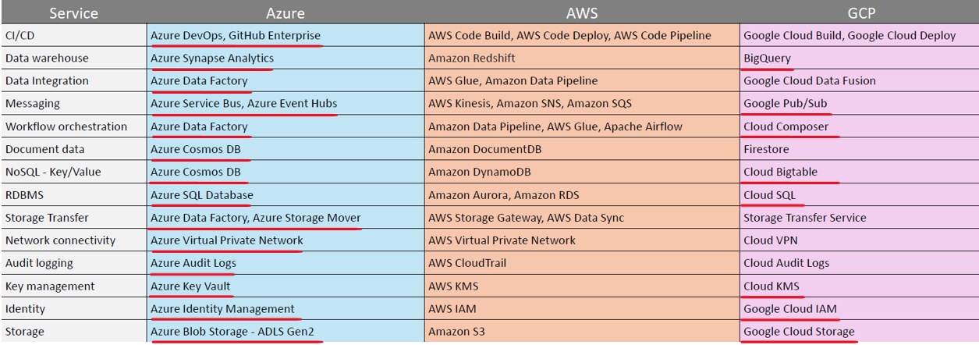

The point is, Databricks is the same on all three cloud platforms. And the decision for going for any particular cloud platform like Azure or AWS or GCP is based on other factors. And those other factors are like which cloud platform your organization is already aligned with or partnered with, or have a strong relationship, which often cloud platforms, offerings, or products your organization is already using for lot of other data engineering or data related, projects or activities, preference will always go to that particular platform. So if we are already aligned with, Azure, or if my organization is already aligned or partnered with AWS, most likely Databricks is also used on the same platform. But from the project perspective, everything is same. The **Databricks platform is same on all three platforms**. The integration part might be little different, which is mostly infrastructure and setup and configuration things.

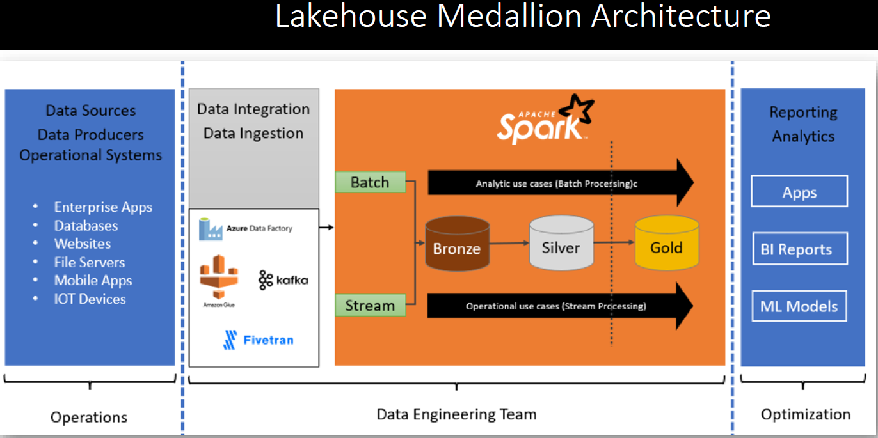

We need to create an Azure Cloud account. Azure offers us a UI to work with the Azure Cloud Platform or Azure Cloud Services. So next thing we will learn about how to use Azure Portal UI.

|  |  |
| --- | --- |
|  | We will make ourselves a little familiar with the Azure Cloud or Azure Portal UI so that you can use it. Then next step would be to create our first Azure Databricks workspace. To get access to the Databricks platform in the Azure, we will have to create Azure Databricks Workspace.  Once we are able to create the Databricks workspace in Azure Cloud, next thing is to make ourselves a little familiar with the Databricks Workspace UI. So Databricks platform is available to us as a web based UI or web based interface. So we will become little familiar with the Databricks Workspace UI. Finally, we will conclude this by understanding Azure Databricks architecture. |

## Azure Account

|  |  |
| --- | --- |
|  | Azure offers you a free Azure account for learning and experimenting.  Let me open my browser and search for create a free account. Here are the results. The first item in your search result is most likely a link to azure.microsoft.com. Let's click that. And you will land on the free account creation page.  Azure Free account offers you some popular Azure services, completely free of charge for 12 months, and you will also get more than 40 Azure services free of cost for all ways. Azure will never charge you for those 40 plus always free services. So you get a lot of things for free. |

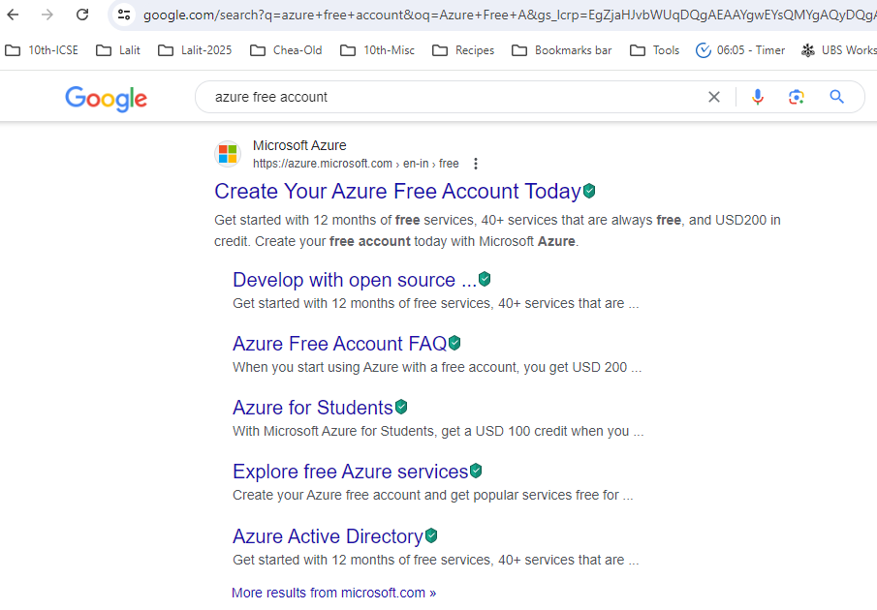

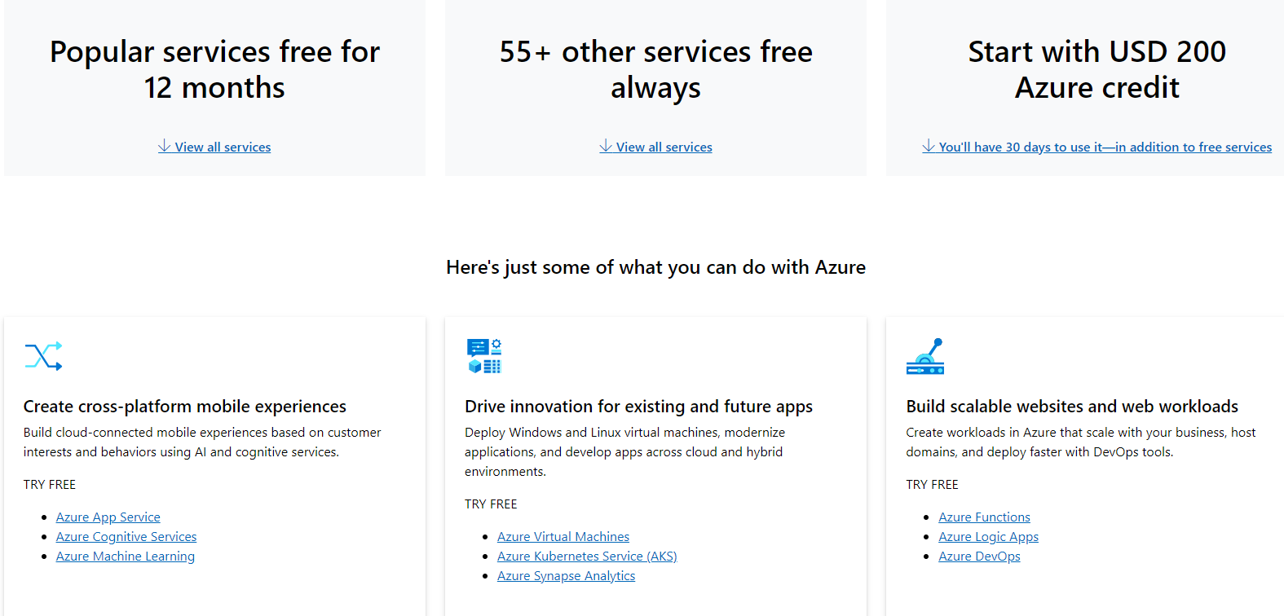

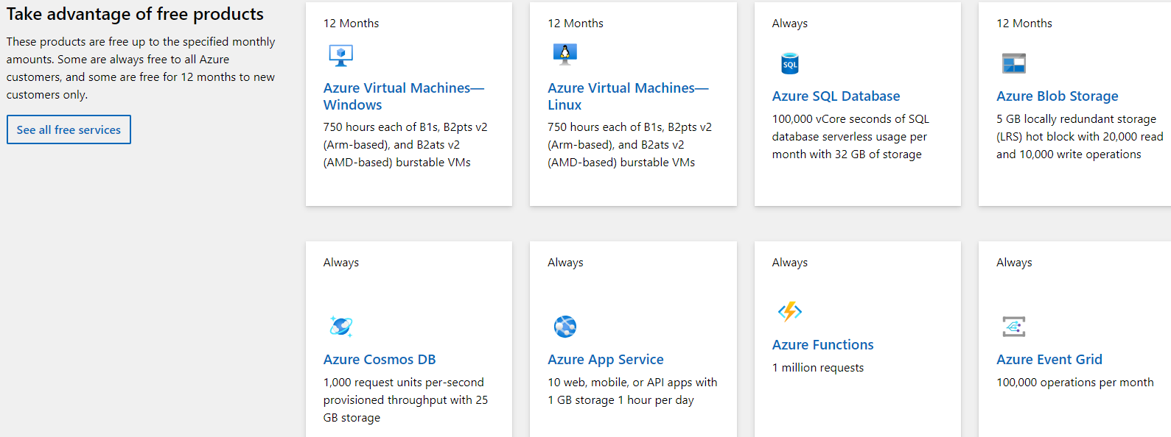

Azure will never charge you for those 40 plus always free services. So you get a lot of things for free. However, everything is not free, but your free Azure account gives you 200 USD worth of free credits. You will be using this credit for the paid services, but this credit is only valid for 30 days, so make sure you finish the course and all the activities within 30 days of creating your free Azure account. These $200 of credit should be more than enough to finish this course.

If you scroll down, you will see a list of some popular free services so you can run a free Linux or a free windows virtual machine for 750 hours every month for 12 months. Similarly, 255 GB of Azure SQL database and five GB of Azure Blob storage is free for you, and these services are free for 12 months with your free Azure account. Similarly, Azure Cosmos DB. Azure App Service and many other services are always free, but every free service comes with some limits. For example, cosmos DB comes free only 1000 requests per second with 25 GB storage. So make sure you understand the free limits of the service you want to use. But you have nothing to worry about the cost of this course, because you are getting 200 USD of free credit for 30 days. And if you finish this course in those 30 days, you are not likely to spend any additional money. You can click this See All Free Services button and see the complete list of free services.



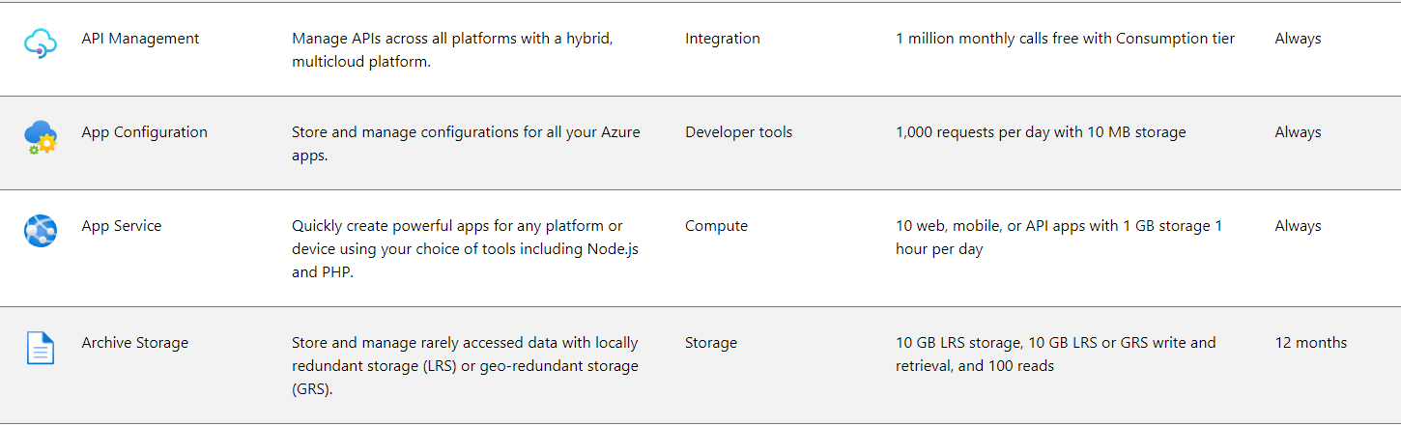

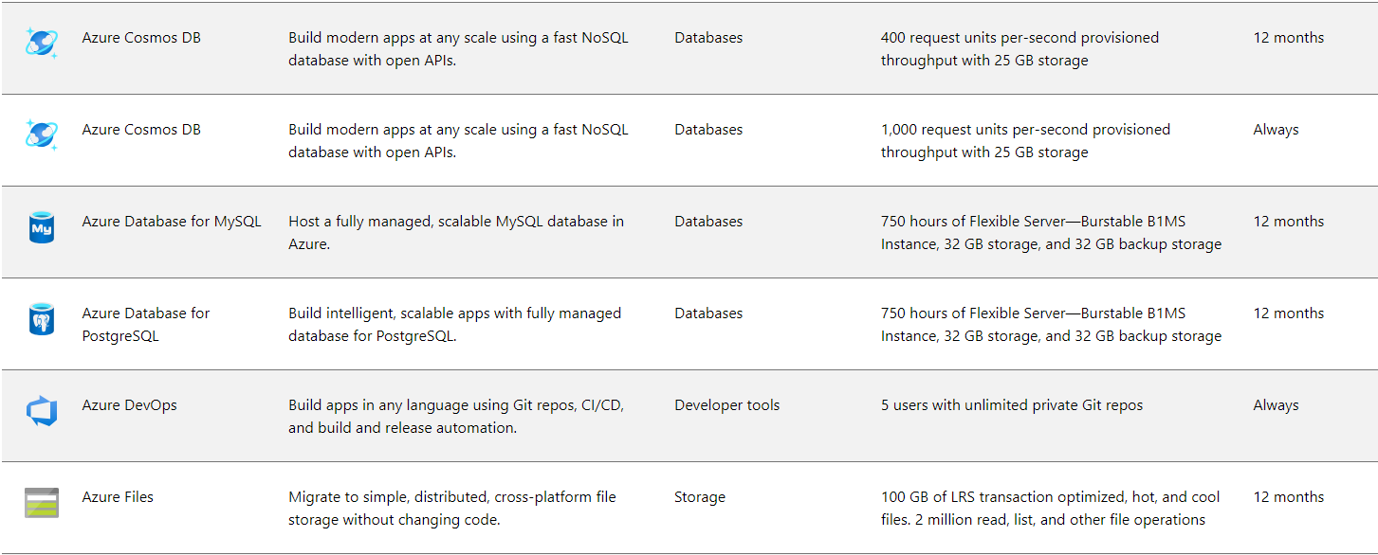

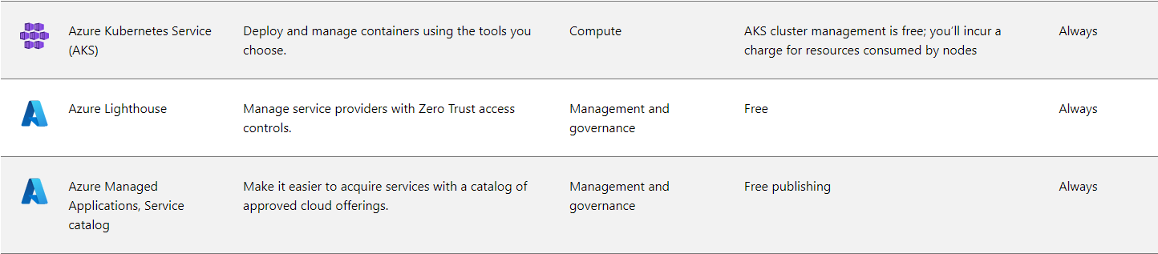





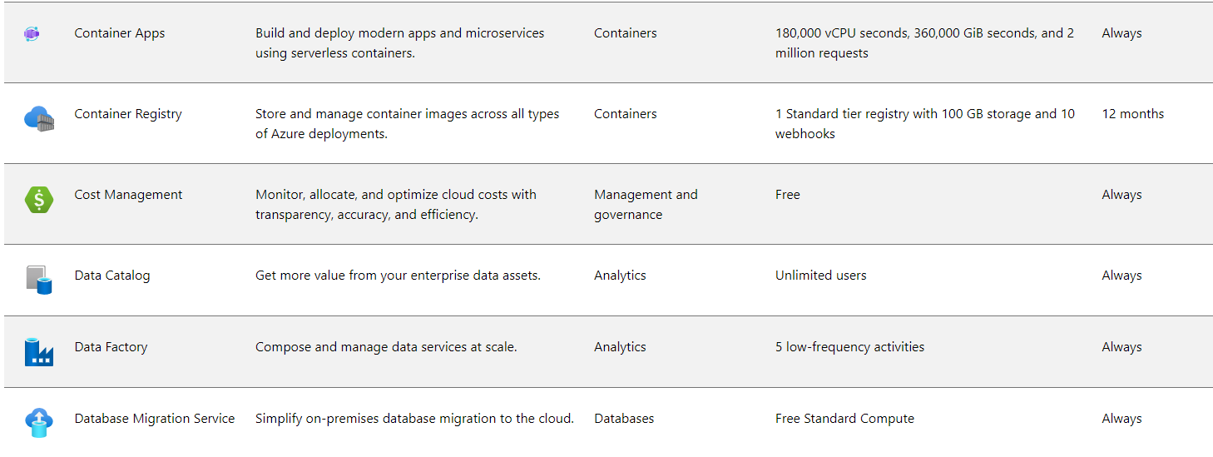







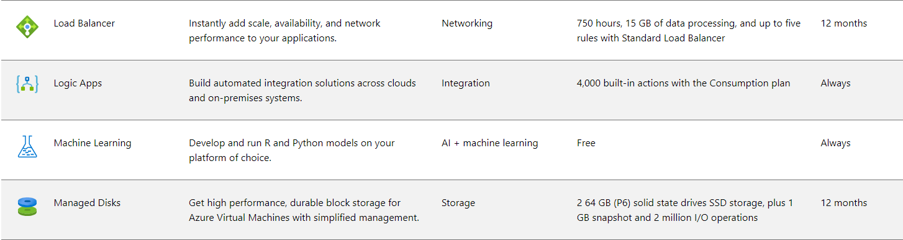

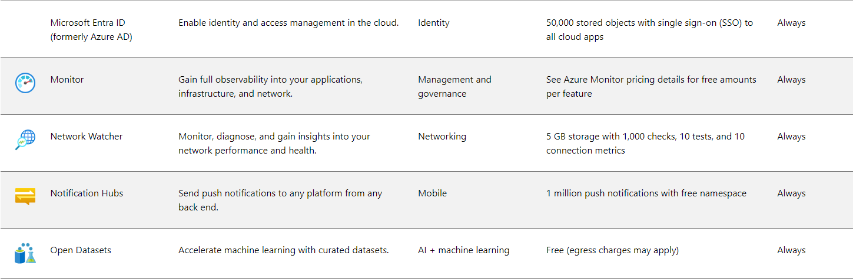

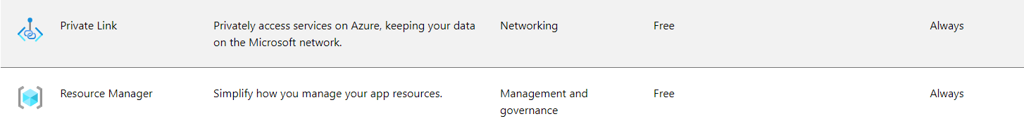

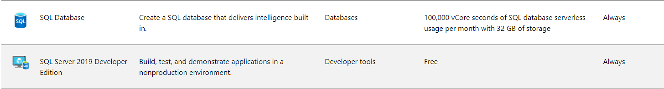

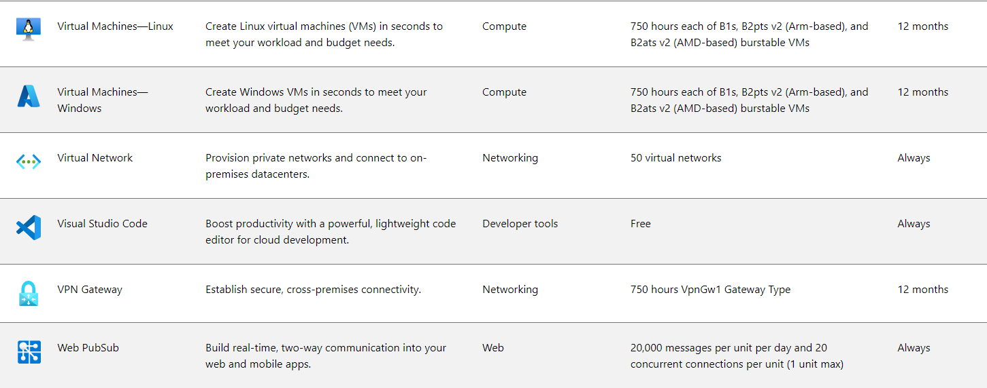

Now let's come back to the top of the page and hit the Start Free button. Microsoft will present you with a screen to sign into Azure Cloud using your Microsoft account. If you already have a Microsoft account, you can sign in to Azure Cloud using the same email address. If you are using a new windows machine you purchased in recent years, you will likely have a Microsoft account. It could be your Gmail ID itself, or your regular email address that you are using to log in to your windows machine. But nothing to worry about. If you do not have a Microsoft account, you can create a new one. I already have a Microsoft account, but I want to create a new one for using Azure Cloud. You can also do that. Let me hit the create link.

So you can use your phone number, or you can use email address to create a new Microsoft account. If you do not have an email address, click this link to get a new email address. And they allow you to create a new email address for Outlook.com. Or you can also create one for hotmail.com. But I want to use my existing email. So let me come back to use your email. Type your email address and click the next button. Create a new password for your Microsoft account and move next. They will send a four digit email verification code to your email address. Check your email. Type in your verification code here and move next. They will be asking you for a Captcha verification in the next step. Scroll down and you will need to do a phone verification. Type your phone number in this box and click the text Me or Call Me button. They'll send you a phone verification code and show you a text box to enter the verification code. Then you should also provide some other details such as your organization name and address. Finally you will click this next button. But make sure you have done your phone verification and supplied your address details and agreed to the terms and conditions before clicking the next button.

Finally, Microsoft will be asking you for your credit or debit card details. They accept credit cards as well as debit cards, but they only accept Visa or Mastercard if you have other types of cards, such as American Express or RuPay card, that's not going to work here. So you need a visa or a Mastercard. It could be a credit card or you can also use a debit card. Provide your card details here, and click the sign up button shown at the bottom of the page. Microsoft will verify your card making a small transaction. For me, they deducted ₹2 in Indian currency. You may also get similar but minor charges in your countries. Currency. If you are in India, they will also register your card for automatic payment of some amount due to recent RBI automatic payment rule changes. For me, they registered for an automatic deduction of up to 200,000 INR, but that's just a registration of automatic payment. They are not going to charge you for your Azure free account.

Microsoft Azure is good at protecting you against cloud charges. Your free account will be free for one month, and Microsoft will adjust any charges against your $200 free credit. After 30 days, your free account will expire. After one month, Microsoft will not charge you for anything until you manually upgrade your free account to a pay as you go subscription. Upgrading your account to a pay as you go subscription is not automatic. You must upgrade your account manually. If you are not upgrading your account, they will not charge your card. So you are protected against the expenses and your card charges unless you manually upgrade your account to a pay as you go subscription. Once your card payment is verified, you will land on the Ready to Start page. Click the go to the Azure Portal button and they will take you to the Azure Portal Quick Start page.

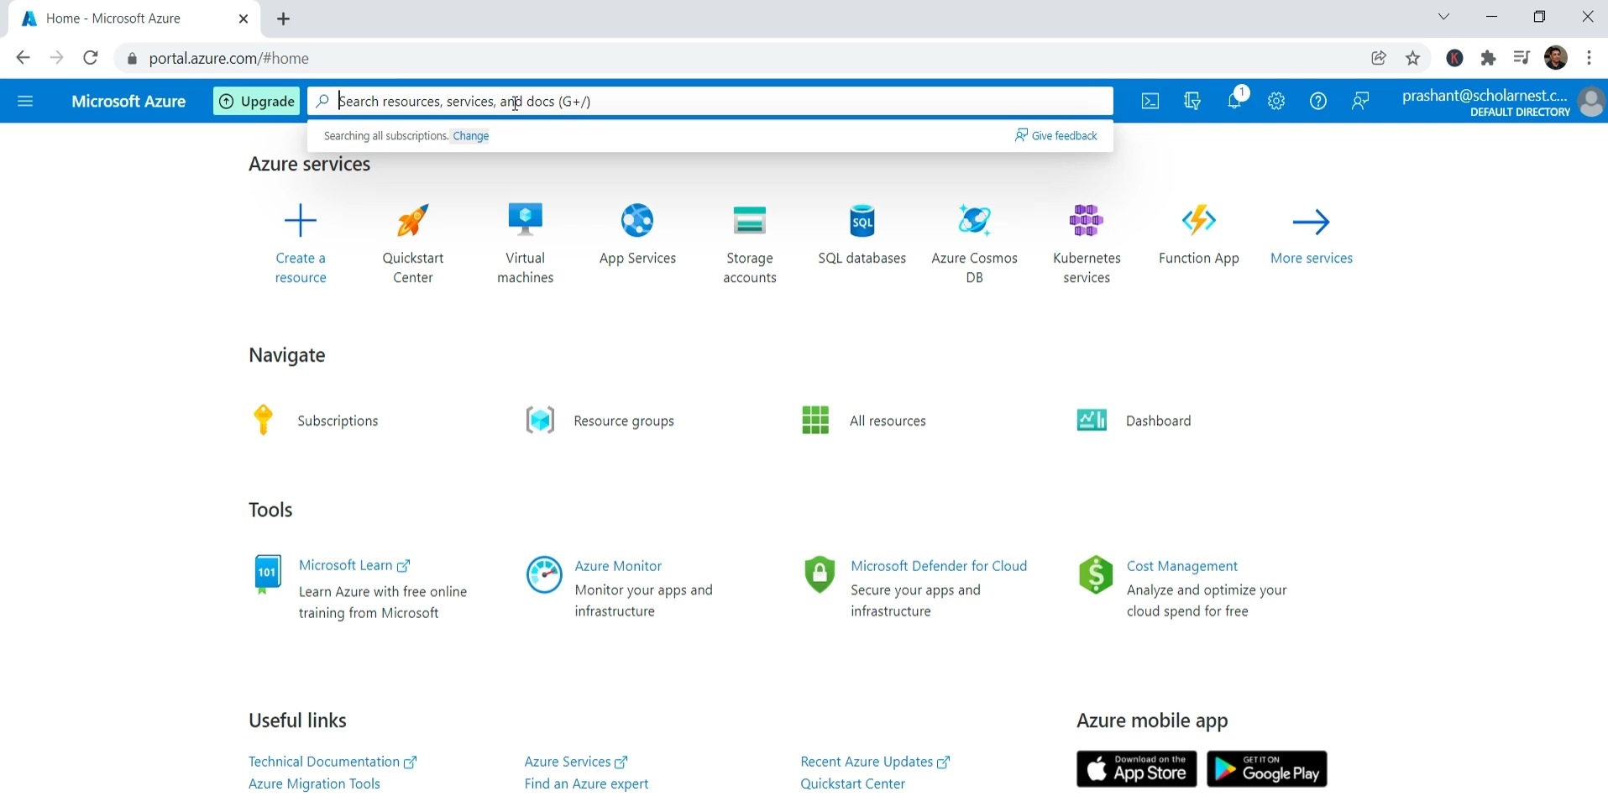

## Azure Portal Overview

Start your browser and visit portal.azure.com. Azure will ask you for your Microsoft account. Choose your account if it is already listed or enter the email address. Enter your Azure Account password and sign into the portal.

The Azure Portal is a web based interface that provides an easy method to work with the Azure Cloud. You can also work with Azure Cloud using command line tools, APIs, and SDKs. However, the Azure Portal is easy to use. Alternative to command line tools. With the Azure portal, you can build, manage and monitor everything from single web apps to complex cloud deployments.

|  |  |
| --- | --- |
|  | So on the home page of your Azure portal, you will see a list of Azure services. You can click this More Services button and see a list of all Azure services.  You will also see some commonly used navigation places. For example, you can navigate to the list of subscriptions and see all your subscriptions. However, you will have only one free trial subscription in the beginning. Similarly, you have links to directly jump to your resource groups. All resources and dashboard. We will be using these navigation links as we progress with the course. On your top left side of the page. You can see a full menu. The menu is nothing but a list of links similar to the navigation links. You can go to the Azure Portal home page, dashboards all services and directly jump to your favorite Azure service. |

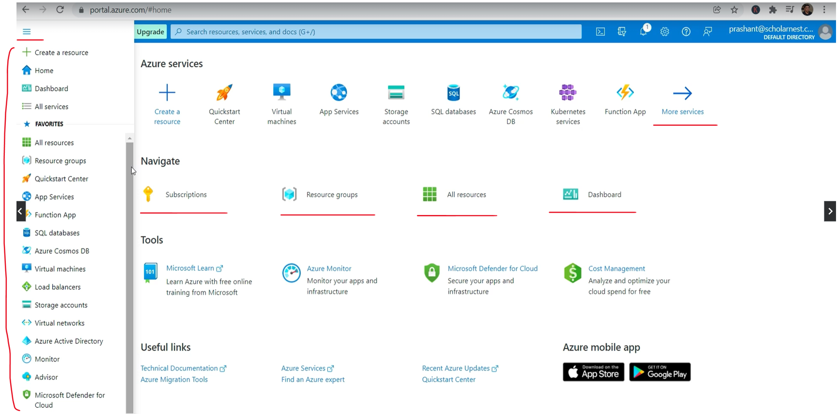

At the top of the page you will see a search box. You can type in any Azure service name to search for it and directly jump to the required service, so you do not need to use navigation links or menu items always. If you know the service name, you can directly search it here. You will also see some small buttons on the top right side of the Azure portal. The first one is to open a cloud shell in your browser. Let me click it. So you can use Linux Bash Shell or Windows PowerShell here in your browser to directly work with Azure Cloud. We will come here when we need to use the Cloud Shell.

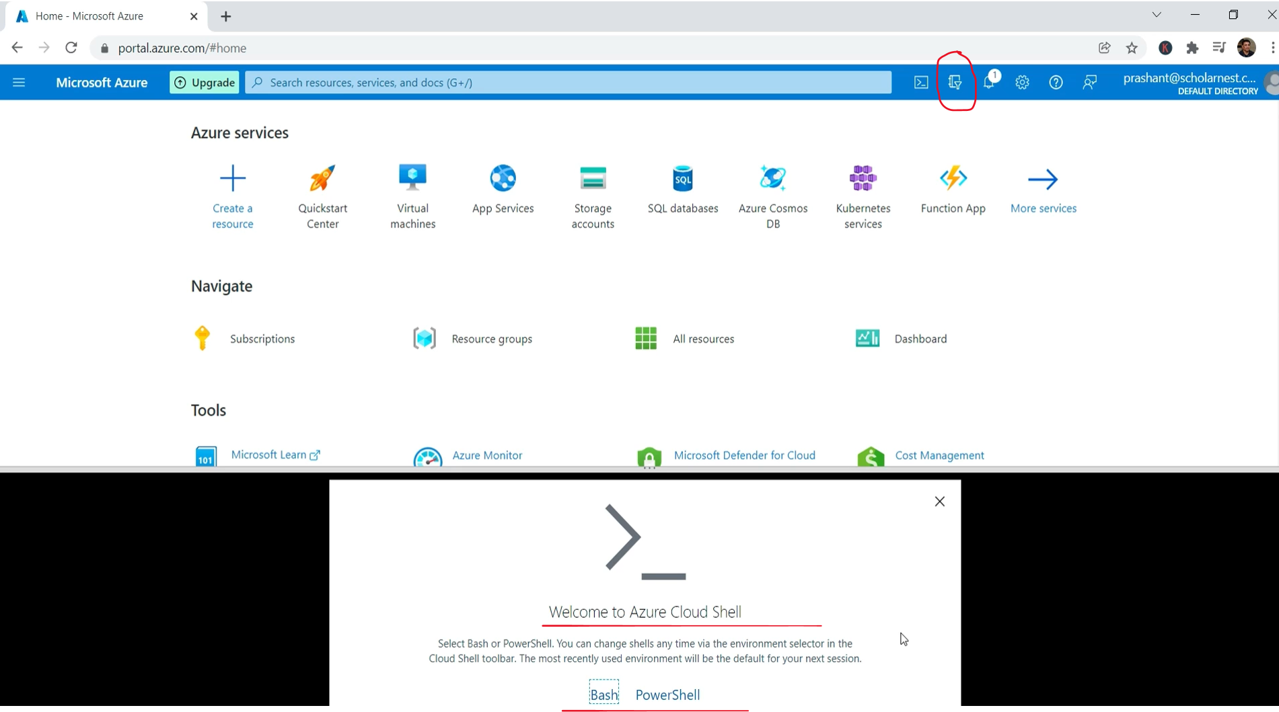

The next one shows you a list of your Azure Active Directory tenant. When you create a new account, Microsoft Azure automatically creates one Active Directory tenant for you. This one is your default Active Directory and you are made administrator of this directory. The default Active Directory tenant is sufficient for now, and you might not want to change anything here.

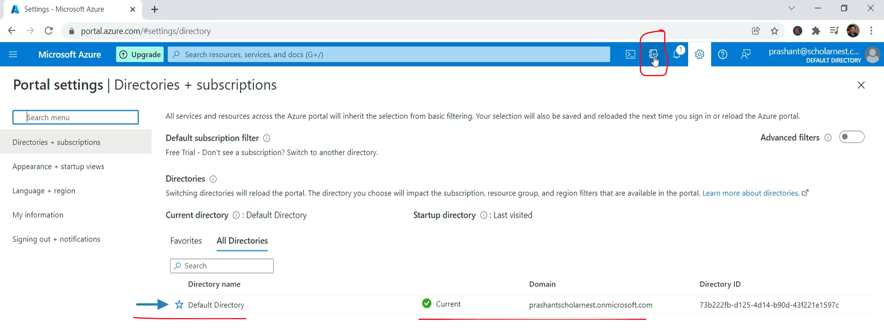

The next link is to your recent notifications. You can see a notification here. I am based in India and my payment currency defaults to INR. So Azure converted my 200 US dollar credits to equivalent INR credits. The notification shows that my credits are still remaining and I haven't used anything yet.

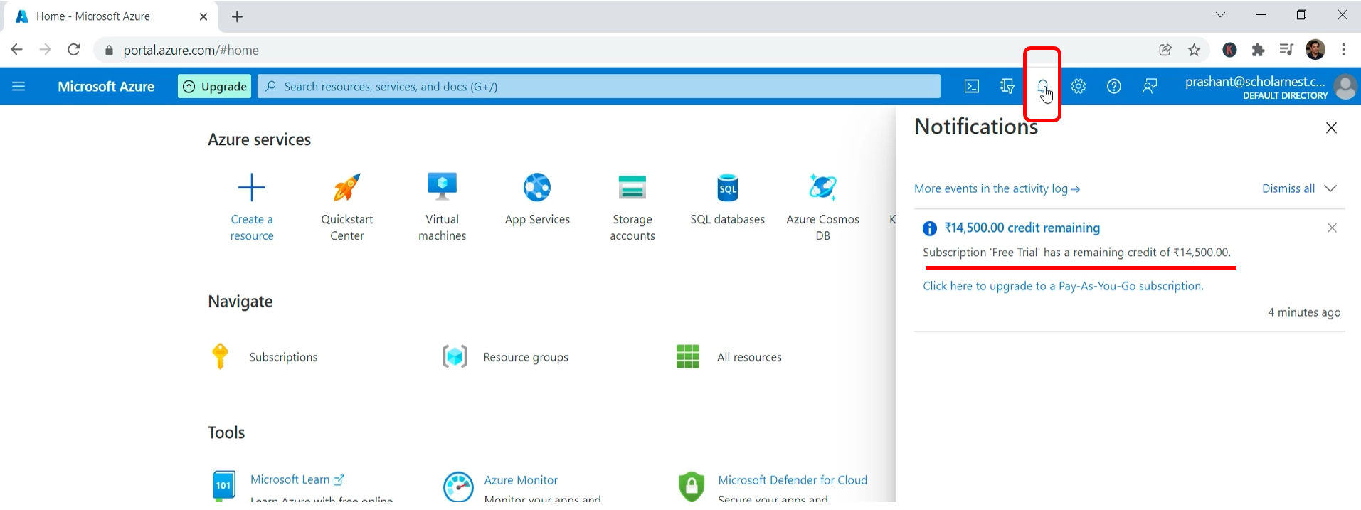

The following link is for settings. You can change your Azure Portal settings from here. For example, click on this appearance setting. My default homepage appearance is selected here. I can change it to show a docked menu. Let me do that. Apply changes. And your Azure menu starts showing permanently on your left side.

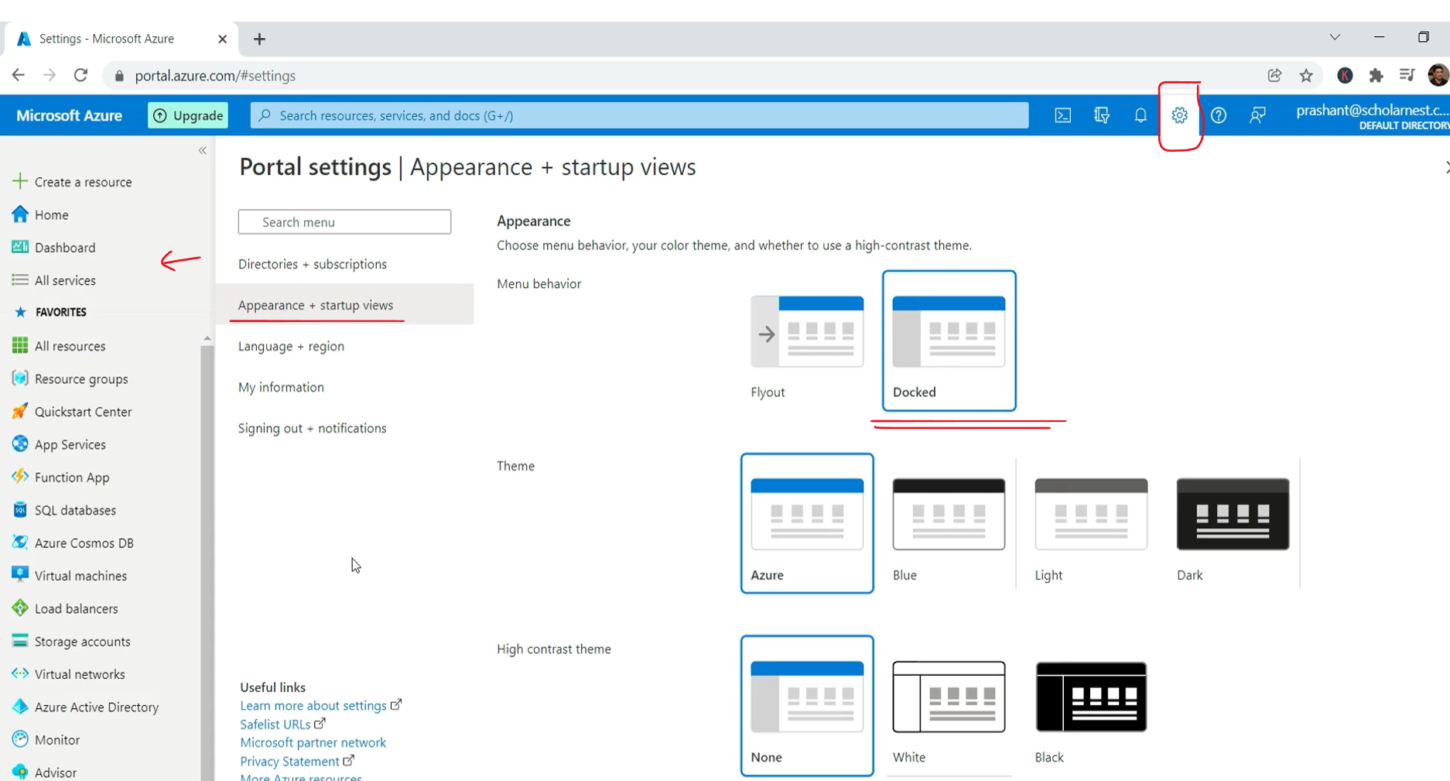

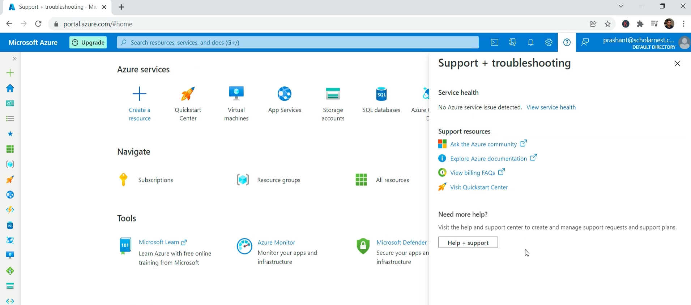

Earlier, I was supposed to click the menu icon to bring it, but it is now permanent. You can minimize it if you want. The following link is the Help and Support menu. Finally, the last one is to send feedback to Microsoft. If you want, you can send them feedback.

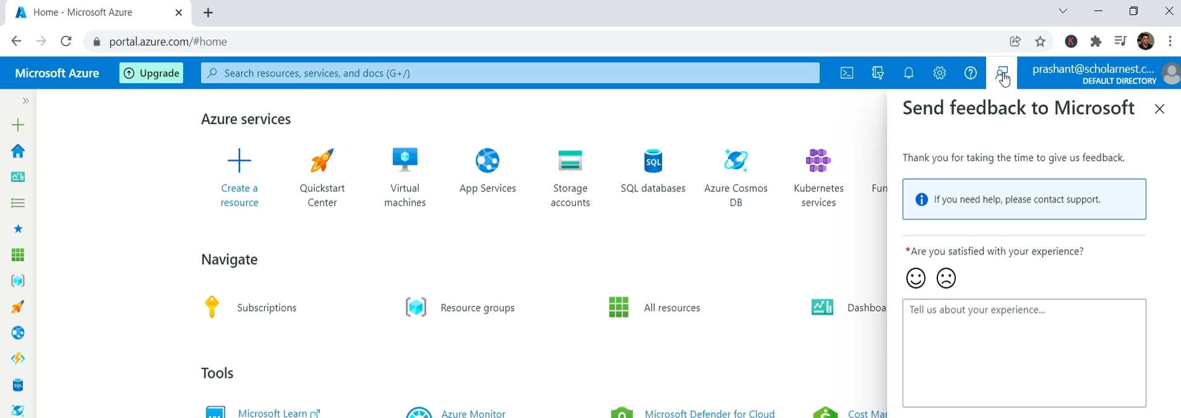

## Databricks Workspace

The Azure Portal home page might not look the same for you as it looks for me. but nothing to worry. On your home page, you might see a link for Azure Databricks. If you are new, you might not see that because this is a list of frequently used services. So if you are new on the Azure portal or you created a new account, you might not see all this, but nothing to worry.

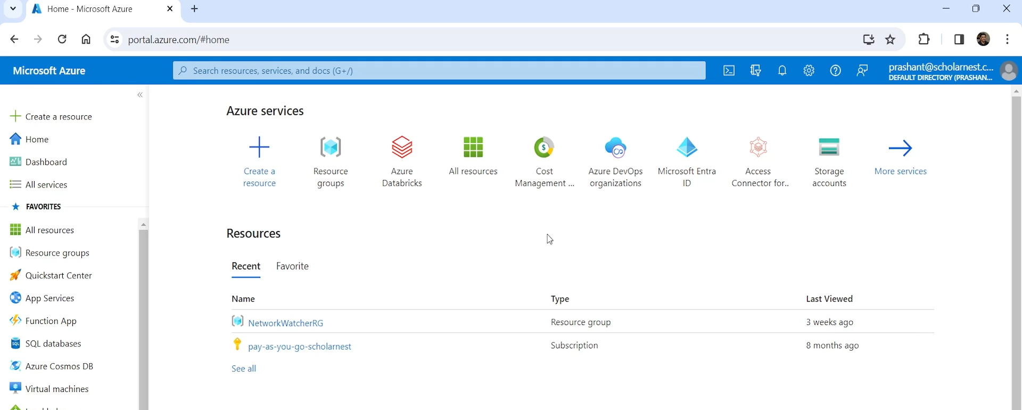

We want to go to the Azure Databricks Service home page so you can go there, simply searching the Azure Databricks in the search bar. So go to search bar and search for Azure Databricks. And you will see a link for the Azure Databricks. Click that link and it will take you to the Azure Databricks Service home page.

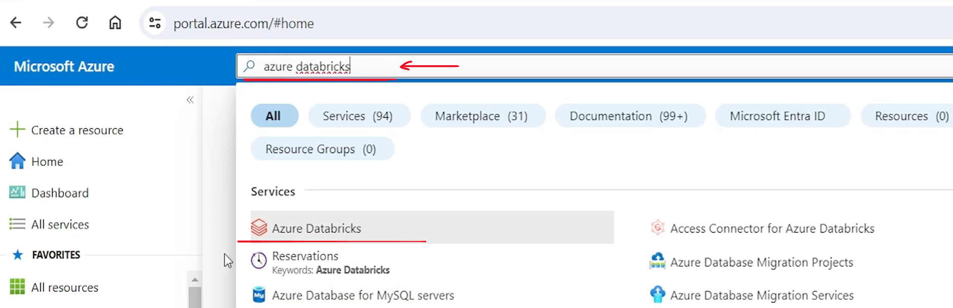

Click that link and it will take you to the Azure Databricks Service home page. And this is the page where you will see all your Databricks workspaces. I haven't created even a single workspace yet, so I don't see anyone here.

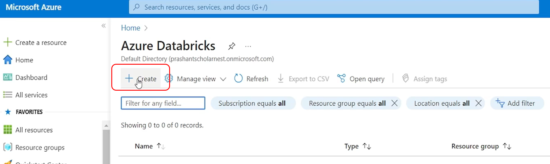

But the idea is for your projects, you might want to create multiple Databricks workspaces, maybe one workspace for one project, another workspace for another project, third workspace for third project, or even you can have multiple workspaces for a single project. For example, you can have one workspace for development environment, another Databricks workspace for QA, and maybe for one more for production. So you may have multiple workspaces in a typical case. But let's start with the first workspace so you can create a new Databricks workspace.

Hit the create button here and Azure will show you a Databricks Workspace Creation Wizard. Here it is. And there are multiple tabs where we can define different things. The first tab is the basic tab. And on this basic tab you have to choose your subscription. Subscription is your billing account. I am using pay as you go subscription for myself. You might be using free tier subscription, but that's perfectly fine. You can use free tier subscription, or you may opt to upgrade your free tier subscription to pay as you go. the recommendation is that upgrade your free tier subscription to pay as you go, because free tier subscription comes with a lot of restrictions, which might not be sufficient.

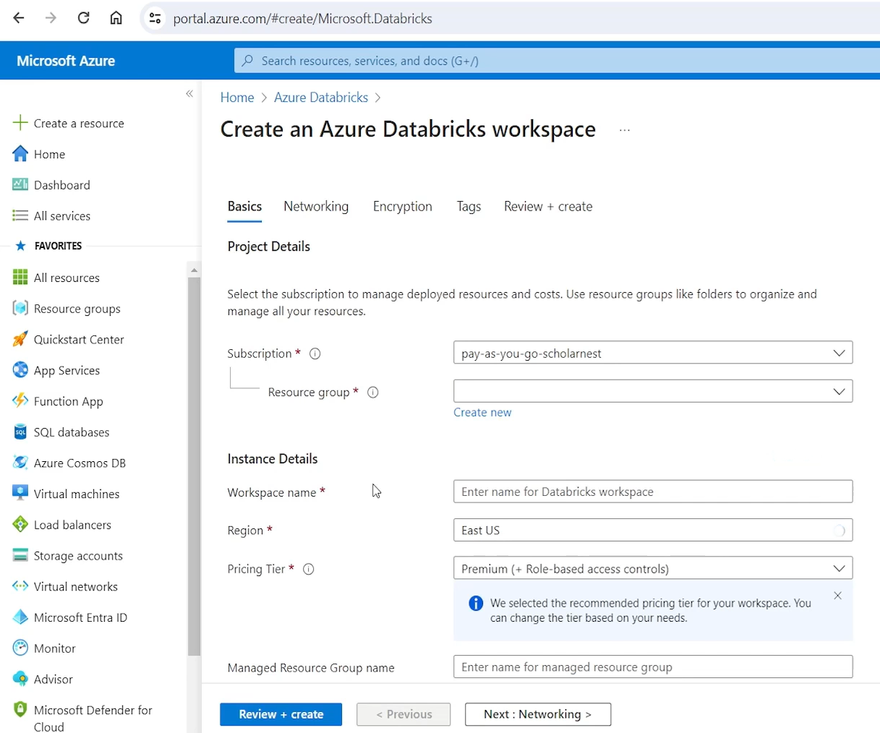

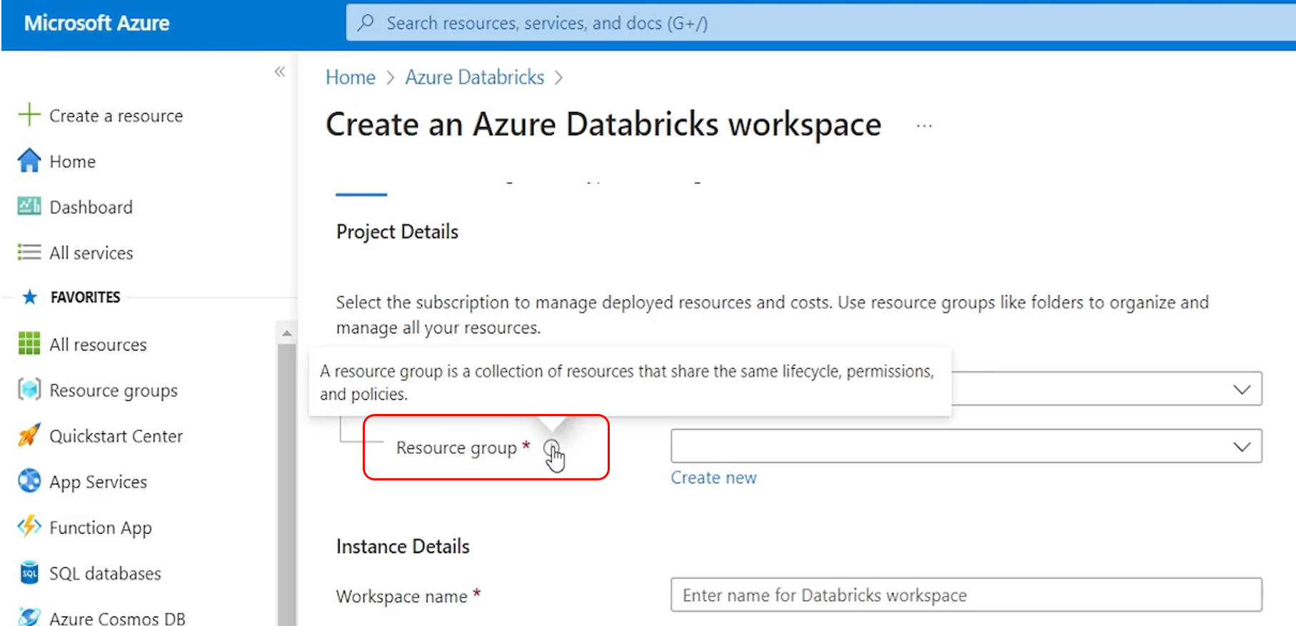

And there are multiple tabs where we can define different things. The first tab is the basic tab. And on this basic tab you have to choose your subscription. Subscription is your billing account. I am using pay as you go subscription for myself. You might be using free tier subscription, but that's perfectly fine. You can use free tier subscription, or you may opt to upgrade your free tier subscription to pay as you go. The recommendation is that upgrade your free tier subscription to pay as you go, because free tier subscription comes with a lot of restrictions, which might not be sufficient. for this course, for doing everything that we want to do, in this course. So you can upgrade your free tier subscription to pay as you go subscription and still use your 200 US dollars free credits for one month. If you upgrade, your credits will still remain with you for one month, and Azure will not charge you anything. It. All your, expenses are adjusted against your $200 free credits. But once your credit expires in a month, Azure will start charging you for your services, which is not very expensive.

I'll keep on helping you minimize your, cost during this course for all your hands on activity. And maybe keep on giving you some estimates of how much, it might cost you for doing what activities. So you can plan to spend some money for your Azure, cloud for learning this course. Anyways, so I'm using my pay as you go subscription. The second thing that we need to specify is the resource group. So what is the resource group. You can get the help here. A resource group is a collection of resources. It's just a name and all your resources or services. Whatever you are creating for your project can be grouped under that name. And that group share the same lifecycle permissions and policies. So what it means you can group multiple resources under a single resource group. So you know that all these resources are related for one project right. And if you want to delete them, you can delete the resource group. And all the resources that are under that same resource group can be deleted at once in one single shot. So it's always, recommended to create one resource group for your project or one resource group for your learning activity and keep everything in the same resource group. So when time comes to clean up, you can clean up it easily. So let me create a new resource group because this is the first time I'm creating, this workspace and I don't have any existing resource group. So let's create a new resource group, let's call it, databricks_course_rg. It's a good practice to, keep some, tag in the name so you can recognize what it is. So databricks-course-rg RG stands for resource group. So I can identify okay. This is a resource group. Click okay. And. Azure will create a resource group for you.

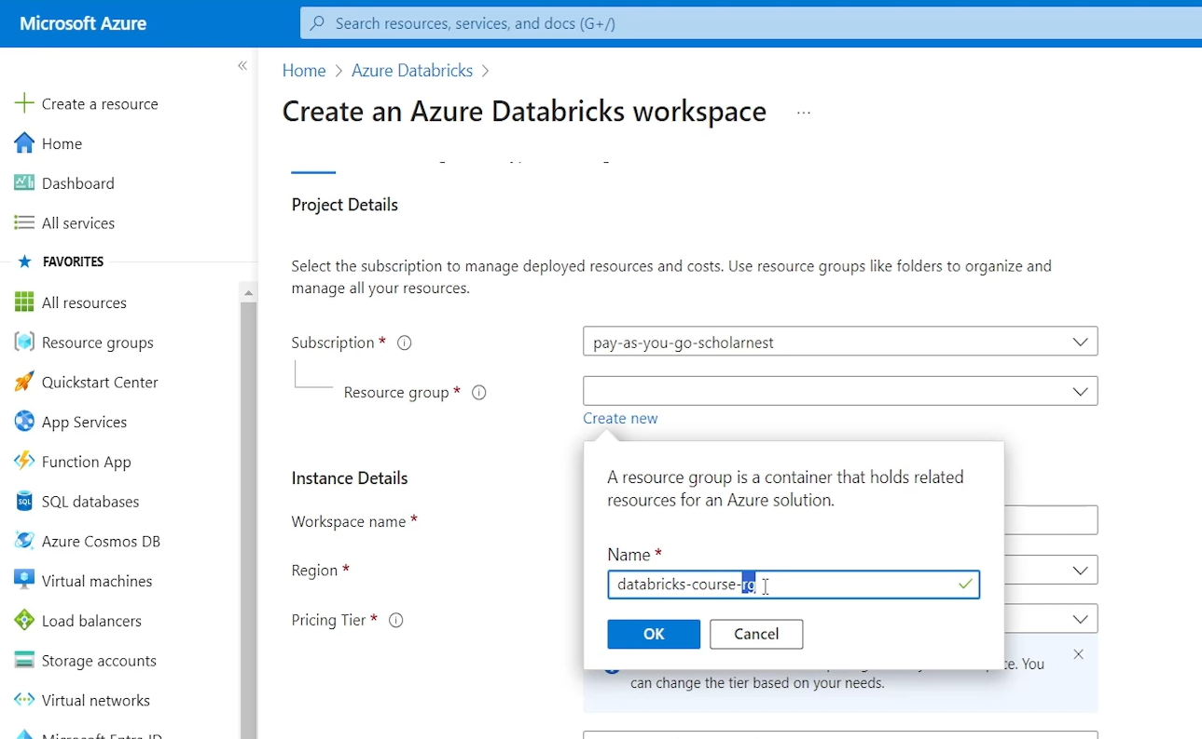

The next mandatory field is workspace name. So we want to create a new workspace Databricks Workspace. So it let's give a name to the Databricks workspace. Let's call it. In databricks-course-workspace. You can call it Dev workspace. You can call it, QA workspace or whatever name you want, you can give. The next thing is to select your, deployment region, your cloud region. So I'll go for us east_US, that's the cheapest region in Azure. So I prefer using us_east. The next item is to select pricing tier. This pricing tier is for Databricks pricing tier Databricks offers two pricing tiers standard pricing tier and premium pricing tier. Standard is little cheap. Premium pricing tier is little expensive. The main difference between standard and premium is role based access control. So premium tier comes with role based access control and few other features are also there in the premi which are not there in the standard tier. You can look for the documentation, Databricks documentation, what is there in standard, what is not there in standard, but in the premium? Everything is there. I'll go for the premium because we want to see everything and choose the premium tier for this. You can go to next button and configure networking then encryption, apply some tags and then finally create the Databricks workspace.

But at this stage it is not mandatory to go all these steps. We can go for the default configurations for that. And you can simply hit the review and create button at right now. So let me hit the review and create button. And Azure will validate all my configurations. If everything looks fine it will allow me to create the workspace. So validation successful. And you can see the create button here right. So let me hit the create button and it will start creating Databricks Workspace for me.

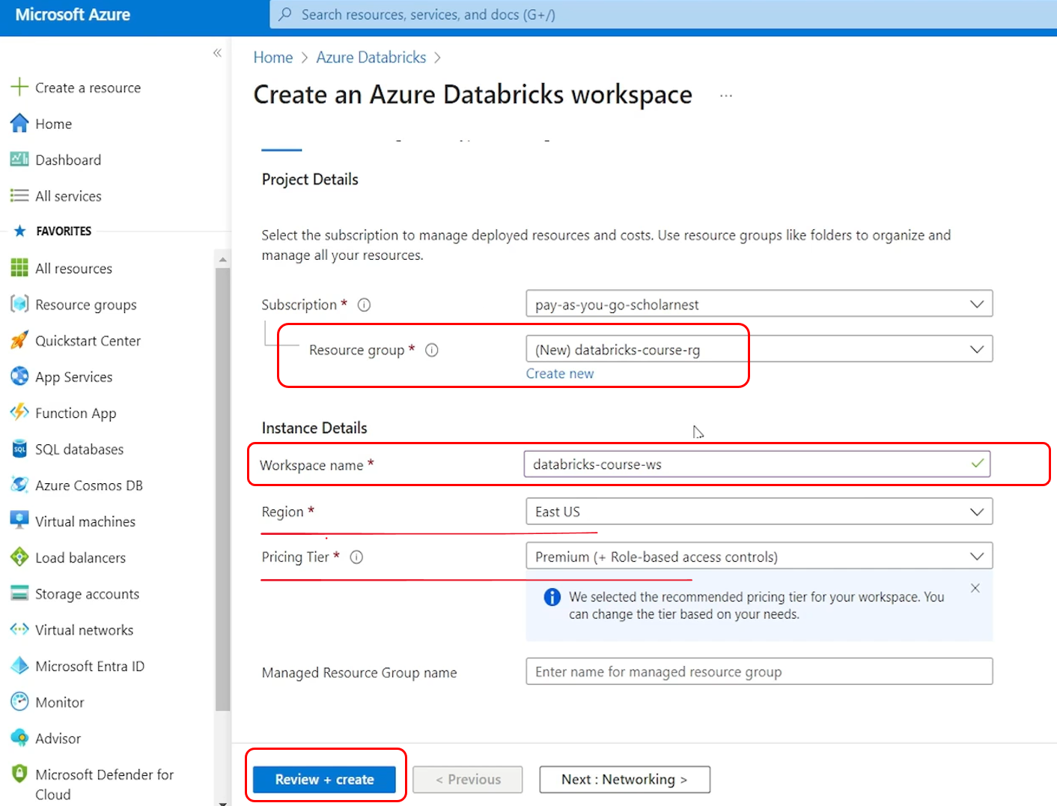

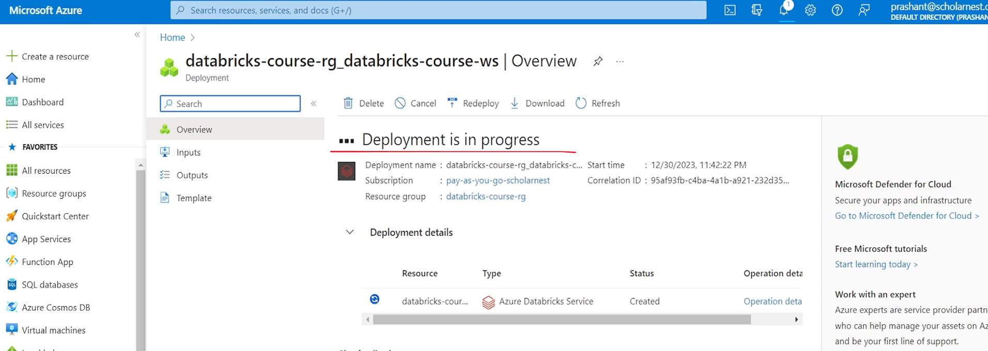

So what is Databricks Workspace. Databricks workspace is nothing but a Databricks application a serverless application. So what Azure is doing it's launching Databricks serverless application for me. And the name for that serverless application instance is Databricks Course Workspace. Right. Once it is ready, I can access the Databricks workspace using a UI and start using Databricks for my data engineering project, for my development activity, for my testing activity, for a lot of other things that we will learn in this course. So deployment is in progress. It might take maybe five, ten minutes to finish the deployment.

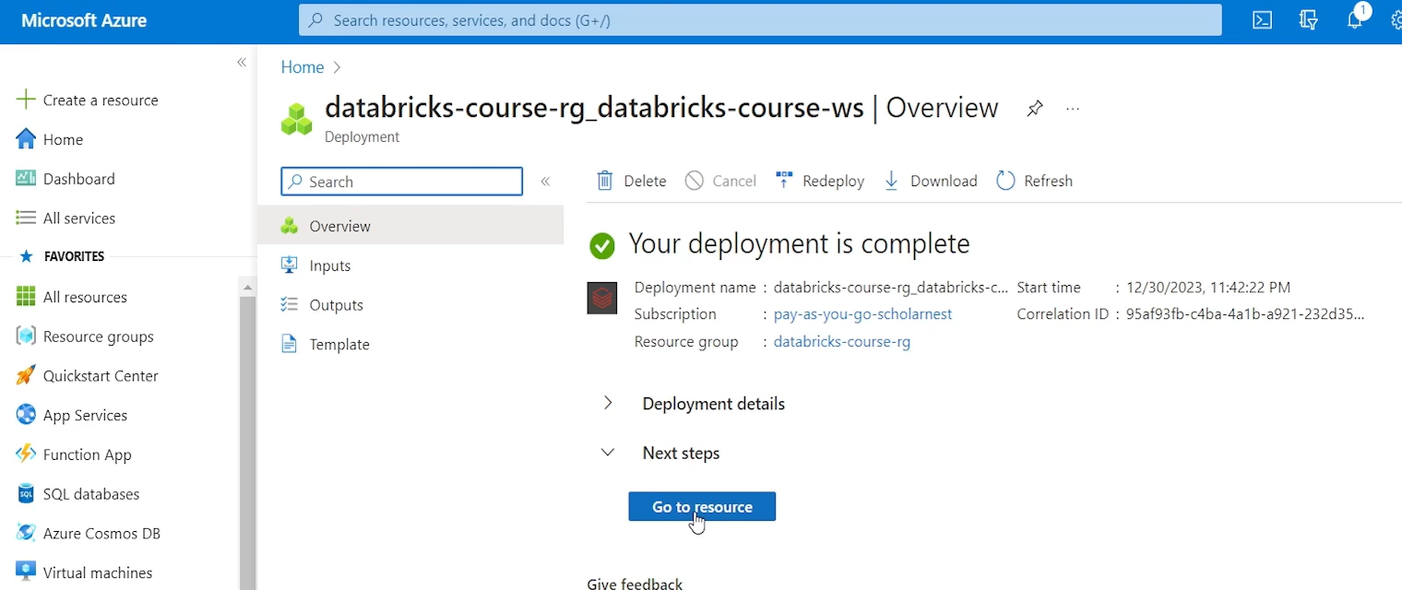

So deployment is complete for my workspace. And you can see a link here. Go to resource. So you can click this go to resource and it will take you to our resource page. So this is my Databricks Workspace resource page in the Azure cloud.

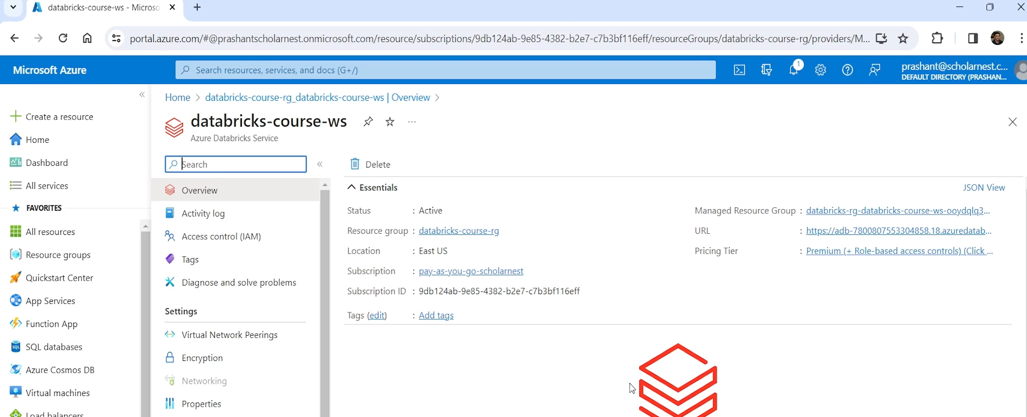

It's not Databricks workspace yet. But if I want to go to Databricks Workspace I can click the Launch Workspace button. It will open in a new tab and it will show me my Databricks workspace. So it's always linked with the Azure account. So, it works on a single sign on. My workspace is already logged in using my Azure credentials, so it's opening for the first time.

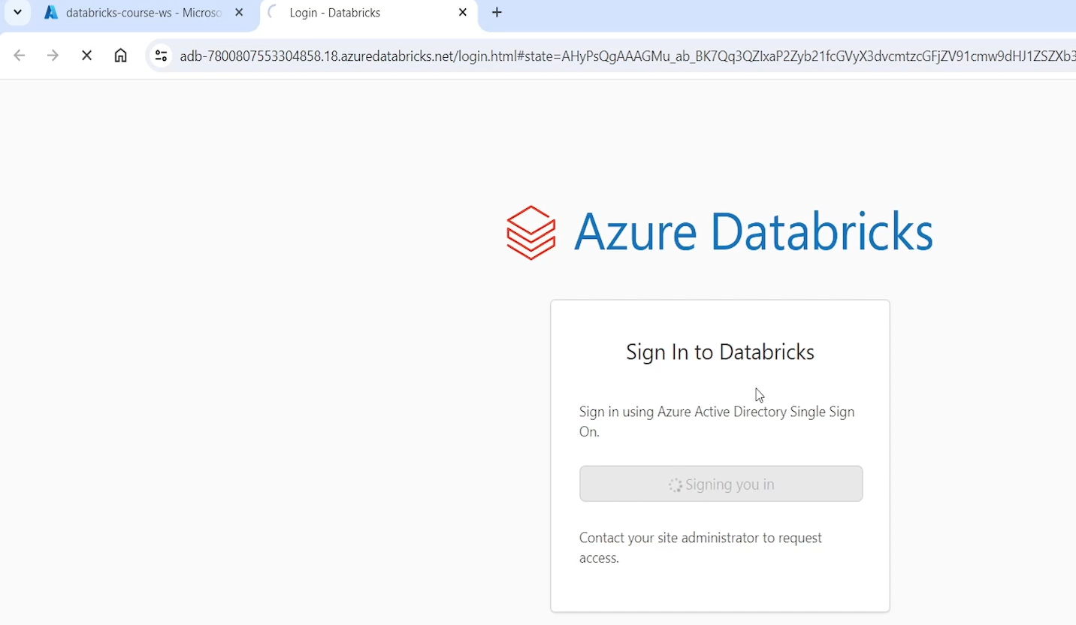

I'll come back to my Azure portal so you can click the launch workspace and go to your workspace page. It looks like this. you can also copy this workspace URL and keep it with you. And whenever you want to log in to your same workspace on this workspace, you can directly hit that URL, in your browser, and it will allow you to log in to your workspace. You may have to give your Azure credentials your username and password. So that's how you can access Databricks Workspace.

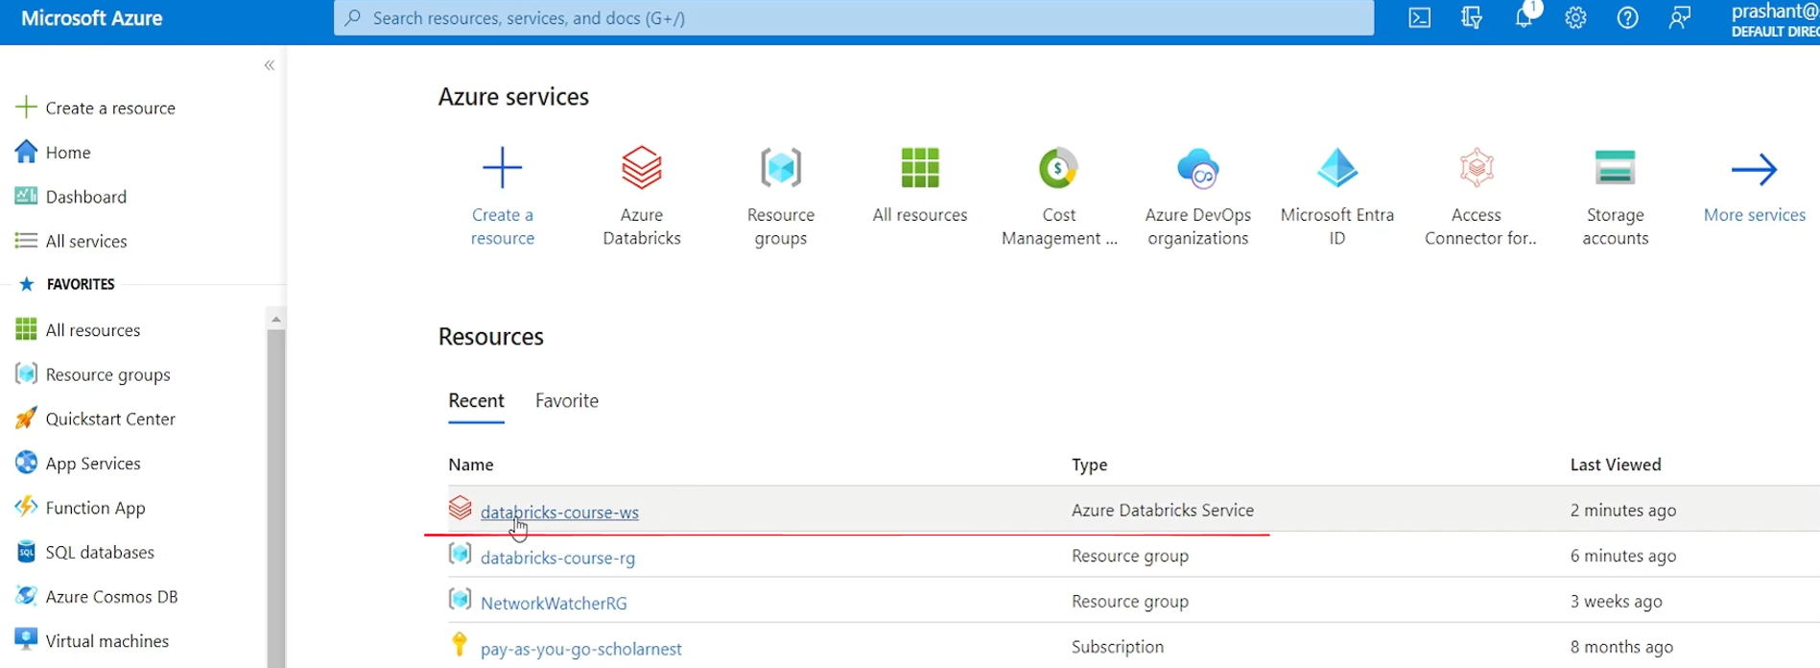

On the next day, if you are coming here, in the Azure portal home page, you might see your workspace listed here. So if you want to open your workspace next day, you can click that workspace from there and you will again see the launch workspace.

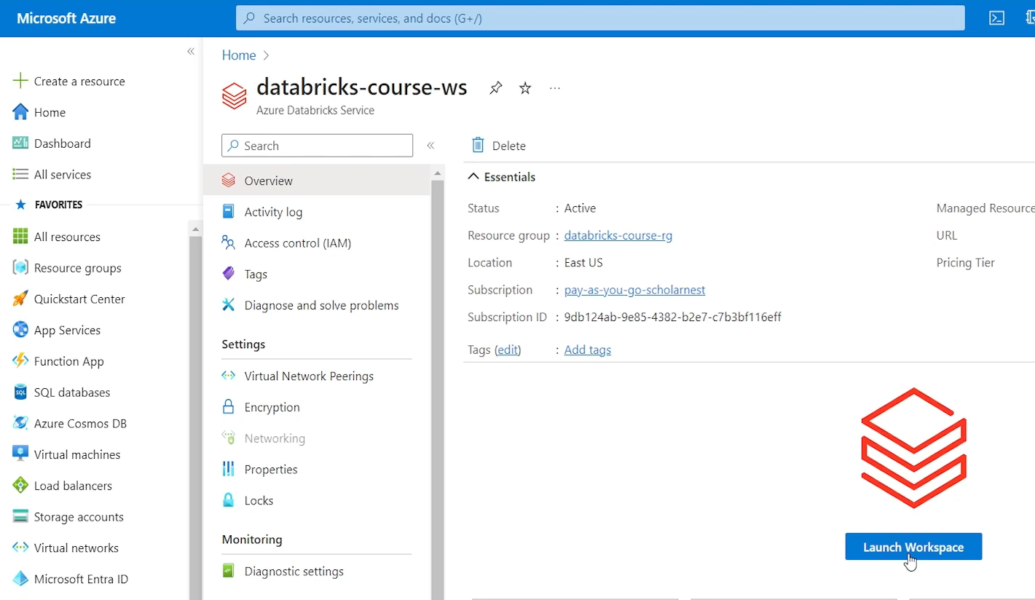

So you can log in to your Databricks workspace in two ways. First is you come to Azure Portal, find your workspace launch page, launch workspace button, and launch it. And it will. Log in to your workspace, or you can keep this URL handy with you and directly hit the URL in the browser, and it will allow you to directly log in to your workspace without going to Azure Portal. Once the Work Databricks Workspace service is created, it might not be necessary to go to Azure Portal for accessing the Databricks workspace. So here is the workspace. And in the beginning it might look like this.

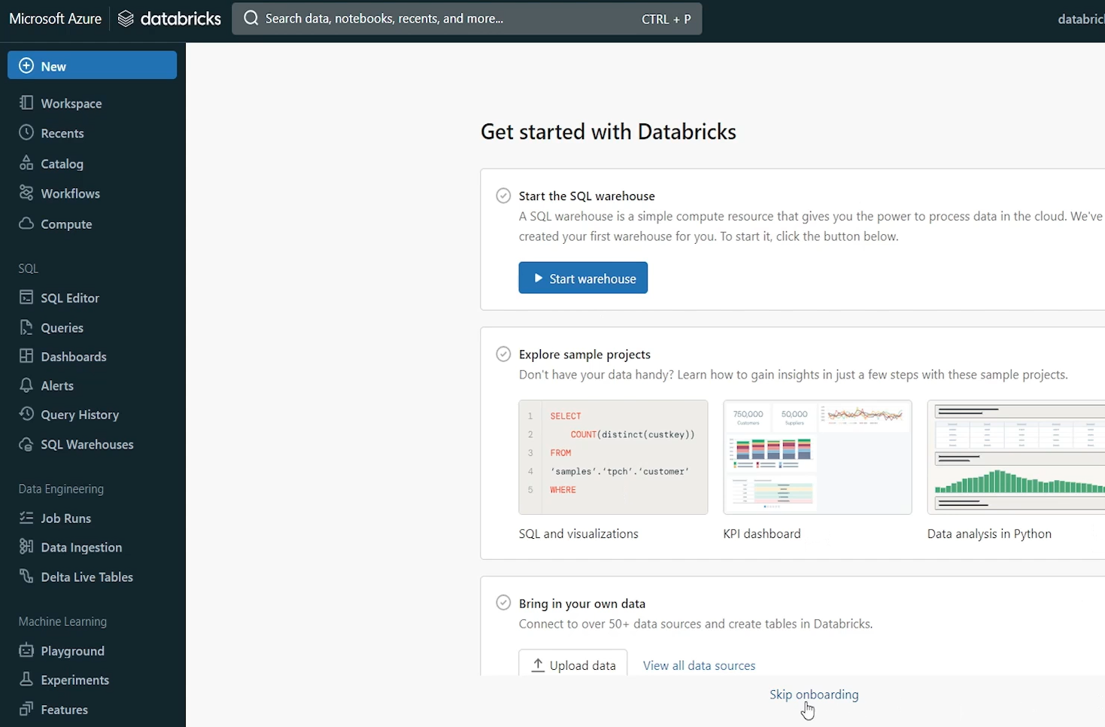

You can click this skip onboarding button and it will go away. They might show some notification here. we are not interested. We can close this. And this is how your workspace Databricks Premium Workspace looks like. In the next video, I will help you walk through the premium workspace, all these, items. And we will become little familiar with this Databricks Platform UI or Databricks Workspace UI. For now.

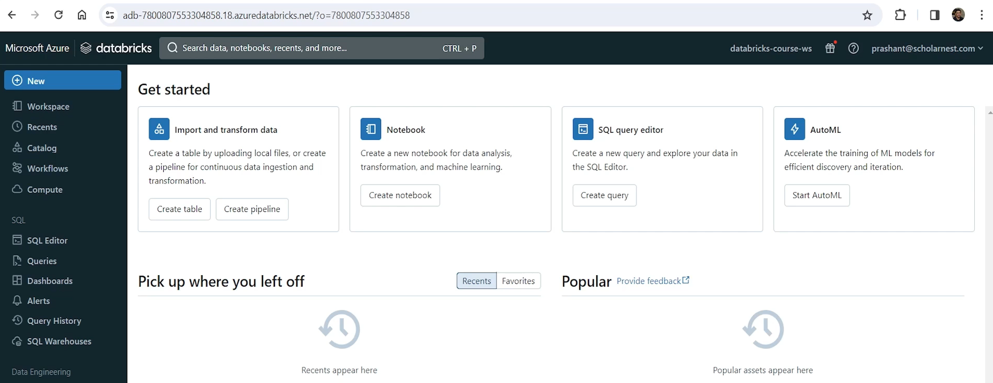

Let me close it. I'll come back to my Azure Portal home page and you can see your resource group here. You can see your workspace here. You might also see Azure Databricks link in the Azure services at the top because you have already used it. So it should be visible here.

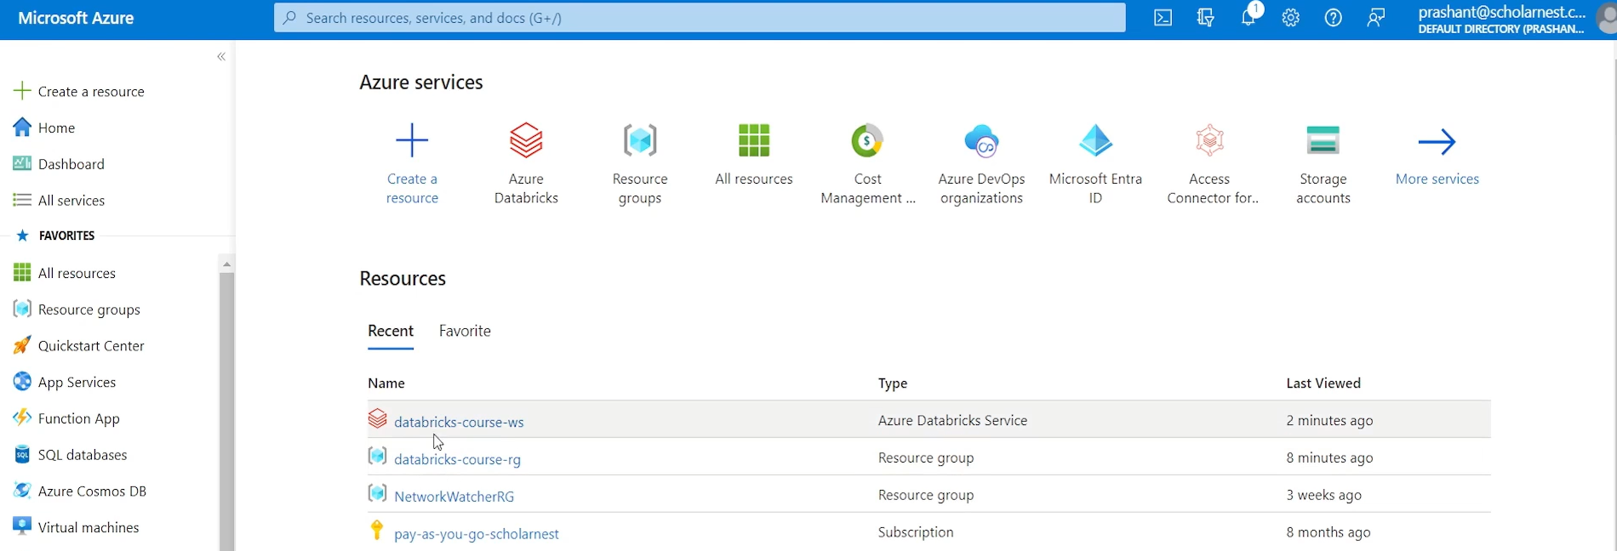

You can come to your Azure Databricks Service home page and you will see your workspace here. You want to create more. You can create more using this create button. All your workspaces will be listed here. And you can click your workspace from here to see the launch button. So there are many ways how you navigate to your workspace launch button. And you can launch your workspace. Databricks workspace is not an expensive resource, so they do not charge a lot of money for creating a workspace. So you might want to create one workspace and keep it there. Do not delete it for maybe a month or two, or until you are done with your hands on activities or practice, for this course. So Databricks, even if you are on the pay as you go subscription data, creating Databricks workspace and keeping that, in your Azure account may not incur a lot of cost for you. If you keep on deleting workspace and keep on creating new workspaces every day. Do not try doing that. You can create a workspace, keep it there for a month or two and it won't cost you a lot of money.

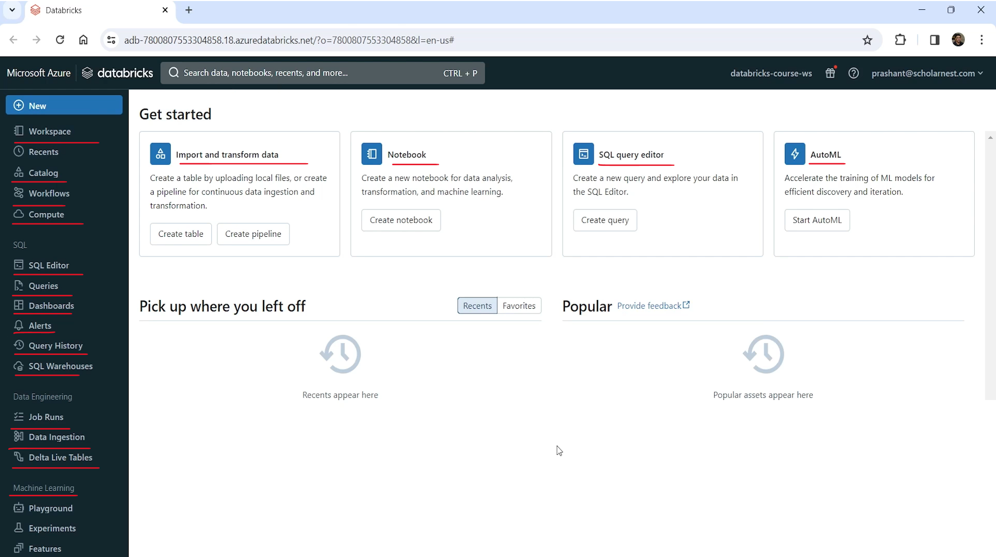

Databricks Workspace is your gateway to Databricks platform. So everything you want to do within the Databricks platform using the Databricks platform can be done from the workspace. So we will keep on coming back here and, learn a lot of things from the workspace itself. But before we start doing that, let me give you a quick walk through the, workspace UI. So on the home page, you will see some links at the top here. These are shortcut links for doing day to day activities. We might not be using any of these. When you start using the Databricks workspace for writing code, for running code, creating notebooks and all that, you will see those items listed here in your recent. And, maybe a few things will come in favorites, but you might not be using too frequently. These things, the main functionality of the workspace is available through this left side menu.

So if you bring your cursor here, it automatically opens it, collapses automatically. maybe you can change it to expanded, menu. I keep it expanded because it helps me to navigate easily and explain things.

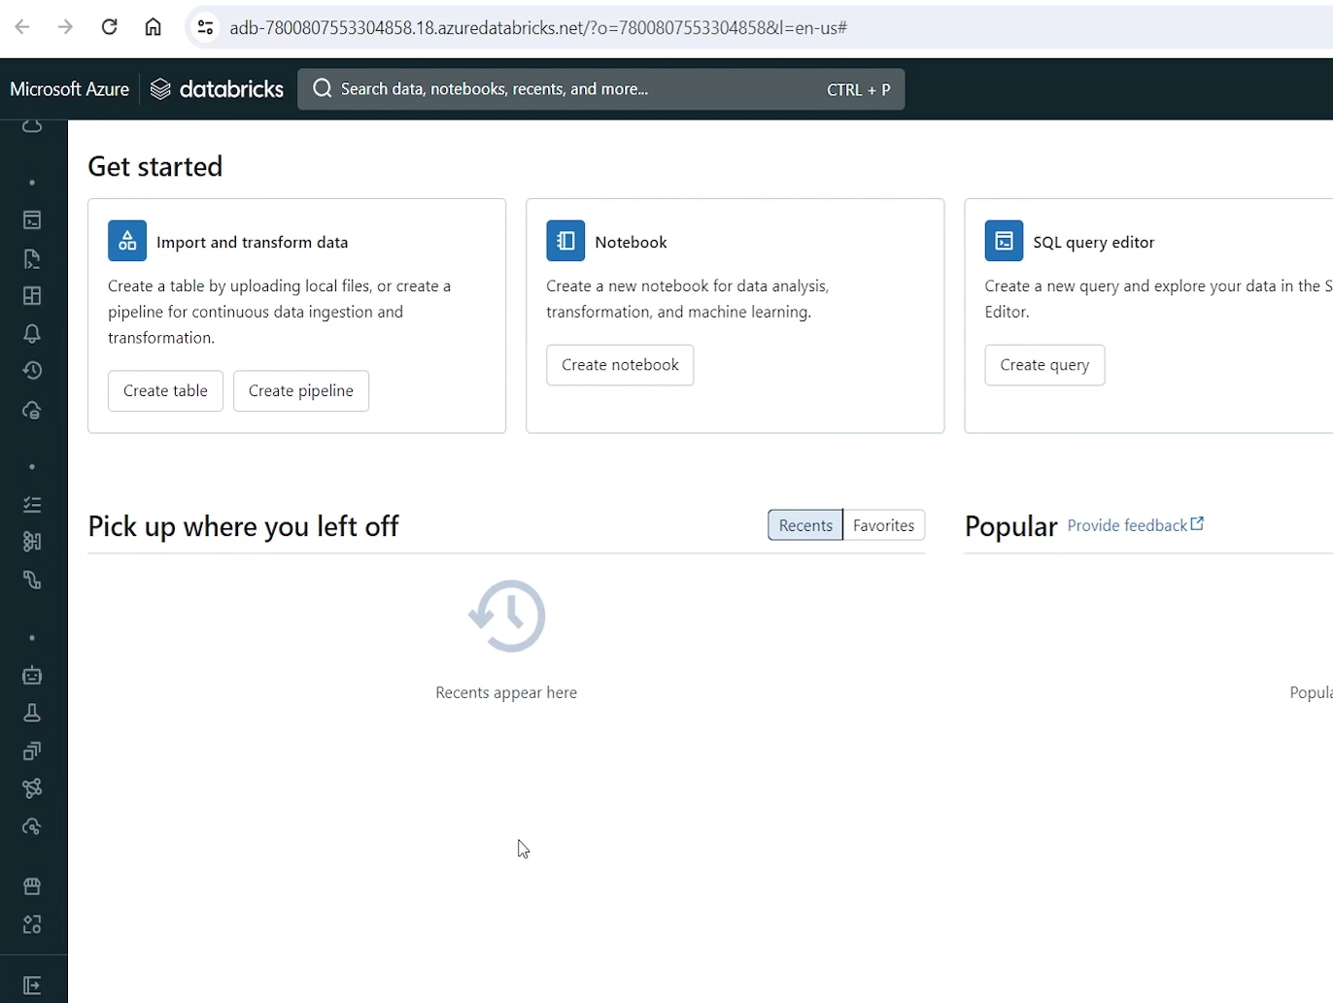

So most of the Databricks workspace functionality is available through these menus. the menu is categorized in different sections. At the top you will see, some most commonly used items. These are mostly relevant for data engineering projects. So we have workspace here. Workspace menu within the workspace UI.

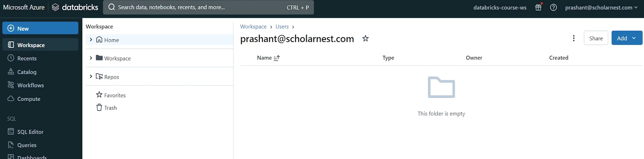

So workspace menu is your, gateway to your, code and directories and files and folders. So if you click the workspace menu you will see something like this. It shows home here. inside home nothing is there. It shows workspace menu. If you expand the workspace, you will see a shared folder and you will see a users folder. These are folders, simple directories. If you go inside the users, you will see home directory for the logged in user. So I am logged in as a Prashanth at scholar Nasscom user. You can see my name here. Also. Workspace name is visible here so you can go to your home directory.

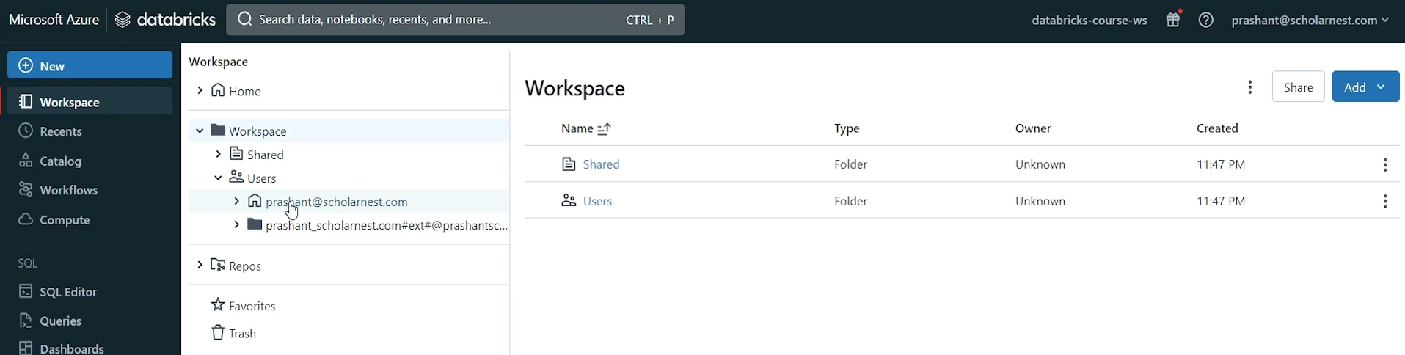

This is my home directory within the workspace. I can come to my home directory and create some resources here. What I can create I can create folders in my home directory. I can create queries, alerts, dashboards, notebooks, files, MLflow experiments, a lot of things we will be learning, some of those things which are within the scope of this course, basically folders, files and notebooks and all those can be created inside my home directory. So workspace inside the workspace menu, the workspace folder is where you will be creating things that will be saved.

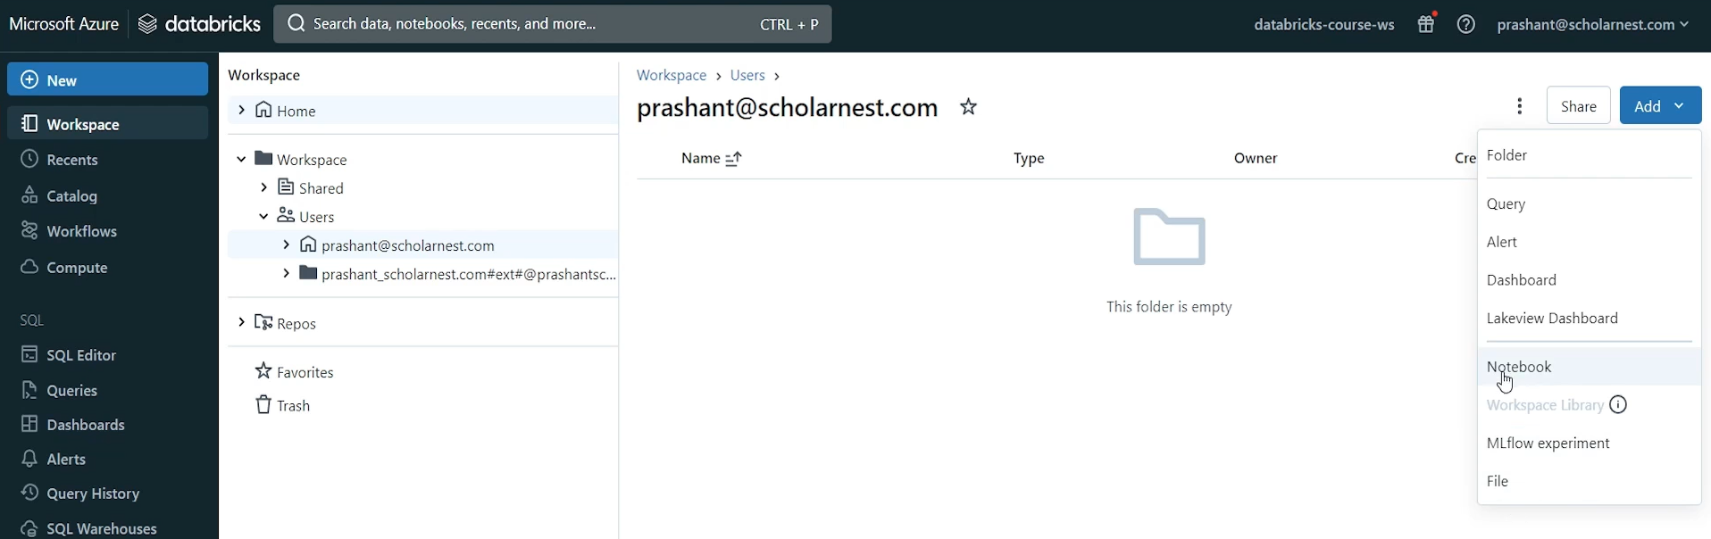

In this workspace you can create directories, you can create notebooks, files and a lot of other things. we also have repos here in the workspace, this is where you can connect your workspace with your source control. For example, you can connect your workspace with GitHub or GitHub enterprise, or you can connect it with Azure DevOps, source code repository. There are two, three, supported options to connect your workspace with the source code source control. And your files will be saved in the source control. And then you can access them from here and work with those files directly. You can commit from here to your source control.

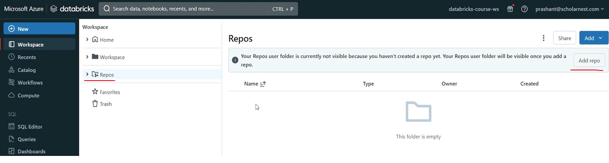

We will learn those things about that later. But the point is that your go to place is workspace menu. In this menu item where most of the development team will login, will come here and create code and run it. Test it from here. recent is a list of recent items. Catalog is a catalog explorer. You don't see a lot of things here as of now, but we will see as we progress with the course. So catalog is known as Catalog Explorer. This is where you will see, metadata information. Your objects like you will see your databases.

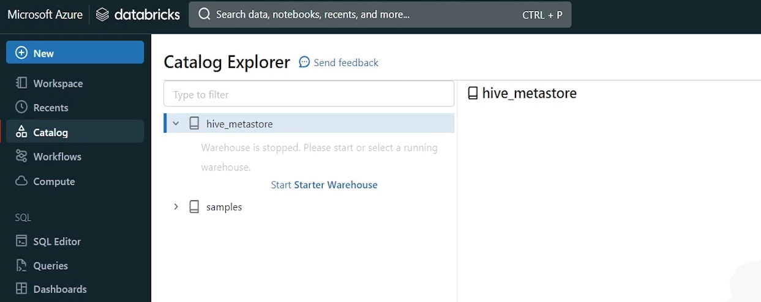

You will see your, tables, views, functions. All those will be visible here. Workflow is the place where you can come to create workflows, right? You can create complex, workflows where you can schedule some tasks and create dependencies between tasks. We will learn about, that later.

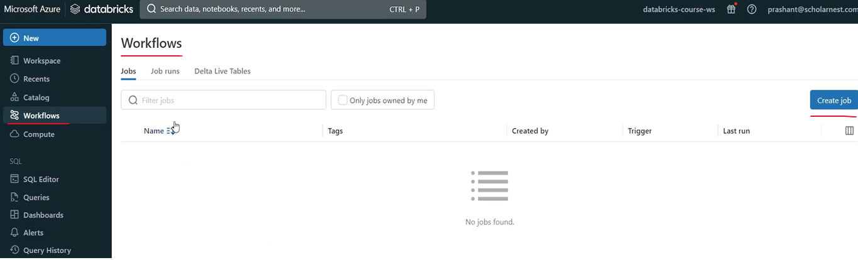

Compute is the place where you can come and create clusters, right? For running your code, your spark code. You need a cluster so you can create clusters from here itself. you can delete clusters, you can terminate clusters, you can manage your clusters. You need not to go back to your Azure portal. And create infrastructure from the Azure Portal Databricks platform. Databricks workspace is the place that allows you to create your compute infrastructure from the workspace itself. We will learn how to create clusters. There are different types of clusters like All Purpose Cluster, Job Compute Clusters, SQL warehouses. You can create cluster pools and you can also define cluster policies.

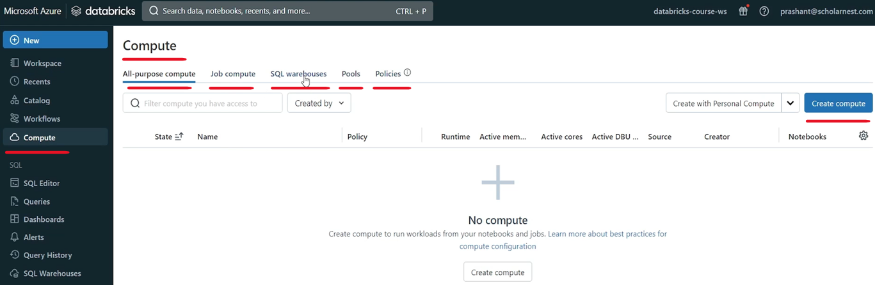

So this is the place where most of the data engineering work is concentrated. Other than that you will see one separate section of the menu here. Right. where the aim to list other data engineering functionalities offered by Databricks. As of now, we see job runs, but job runs actually, comes to the workflow. So if you click job runs, you will come to the workflow job runs tab. If you come to the work click the workflow, you will come to the Workflow Jobs tab.

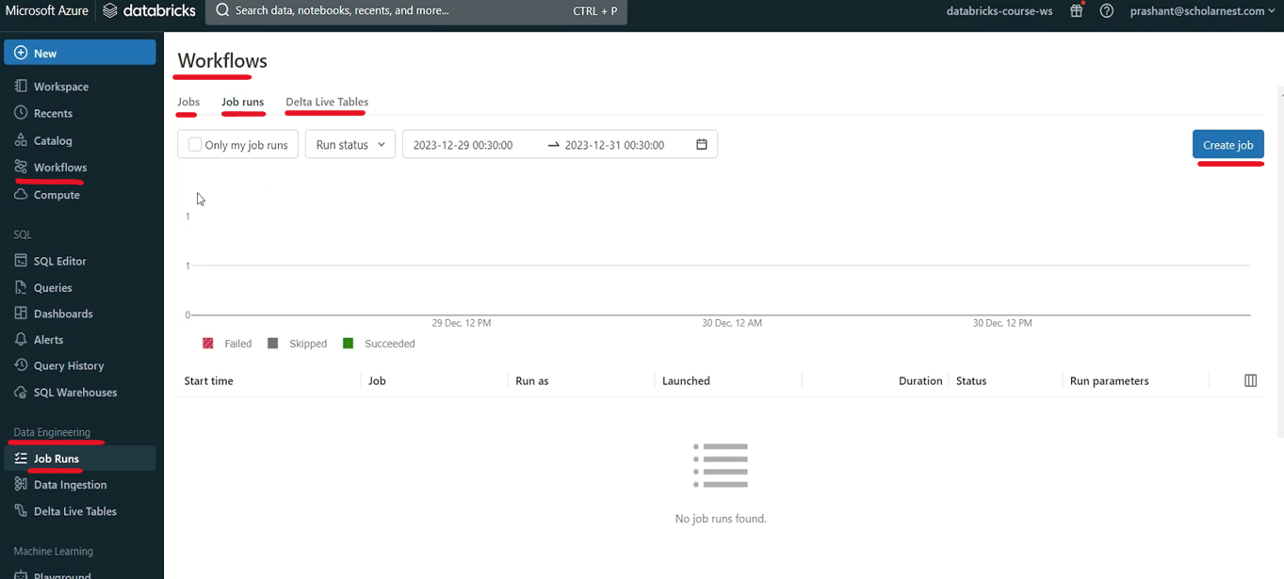

Data ingestion. You click that and this will take you to a page where you can use some partner solutions or some inbuilt solutions in the Databricks platform to ingest data from various sources. So here is a list of native integrations. These are, native integrations available in the Databricks platform itself, using spark to ingest data from sources.

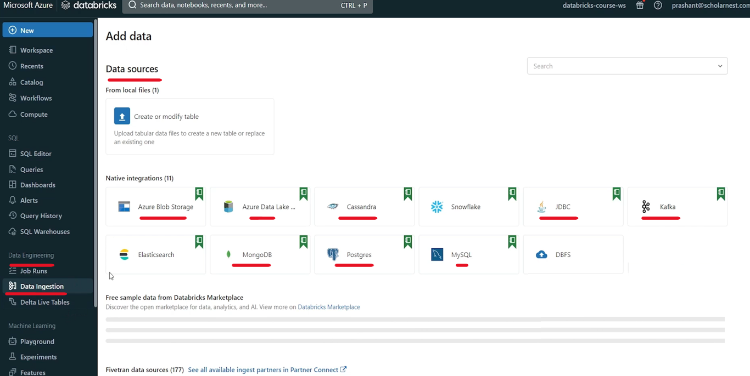

There are other partners like Fivetran. So other sources are available through partner, tools.

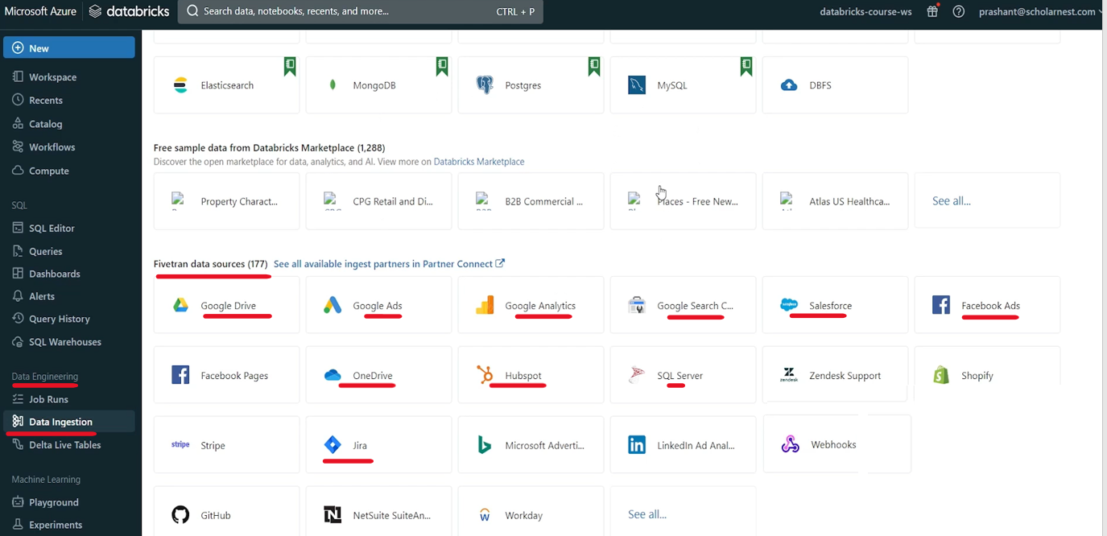

So data ingestion is the place where you can come and maybe choose a suitable partner tool to ingest data from the source system into the Databricks platform or into your Lakehouse platform. There is one more option here. Delta Live Table. Delta Live Table or DLT is Databricks offering for declarative ETL. Basically this link also takes you to the workflow page. So if you come here workflow page default tab is jobs tab. But you can jump to Delta Live Table tab. Or you can click Delta Live Table from here. And it will directly take you to the workflow Delta tab.

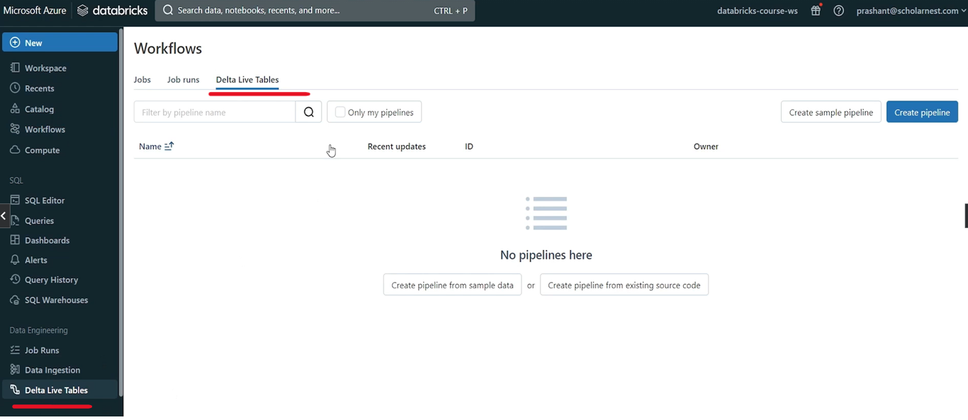

So these are the main places where data engineering team or data engineering activities are concentrated. You will be using these menus. Sometimes these menus as a shortcut, but all these functionalities are also available through these menus. And we also have two more submenus like SQL. if you look at this. So Databricks is also, serverless on Cloud Data Warehouse. They have that offering All those functionalities, data warehousing functionalities or data warehousing capabilities are available under the SQL menu. So you can create serverless SQL warehouses. You can define queries, you can use SQL editor, you can create dashboards. You can define alerts. You can look at the query history. All those functionalities are available here.

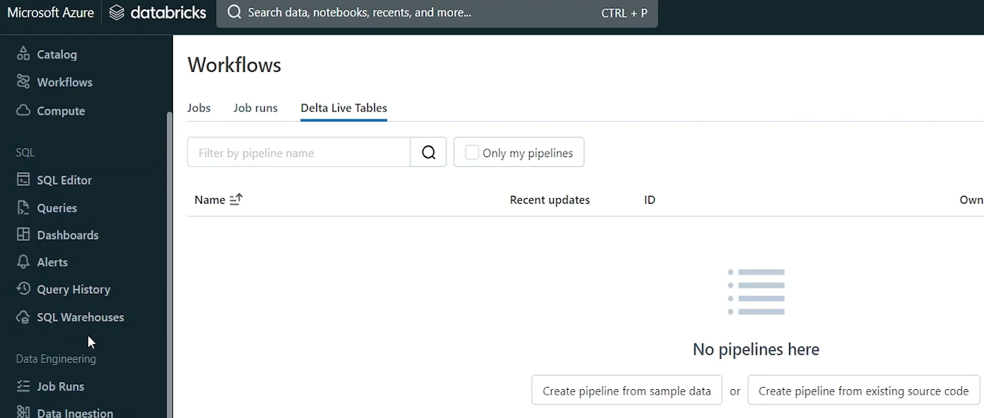

Databricks is also a platform for implementing machine learning algorithms. So those functionalities are available under Machine learning menu. So all these are part of the machine learning menu. So if you minimize these areas and keep it like this. So most of the data engineering activities are concentrated here. We also have marketplace and partner connect.

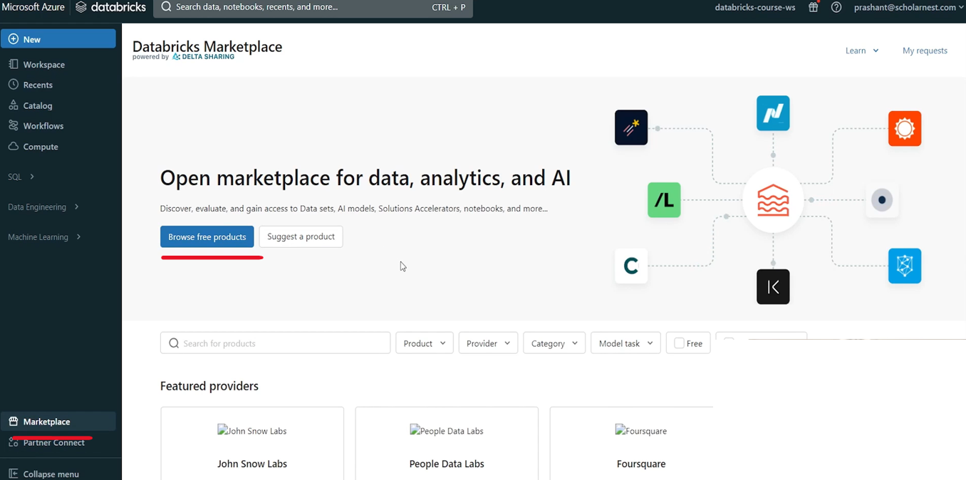

So marketplace is so marketplace is a place where other organizations or partners or different vendors are selling data. Some are giving it for free, some are giving it on paid. It is powered by Delta sharing. So you can see there are, different vendors selling different kind of data here. Similarly, Partner Connect is a place where you will see different partners. So let me cancel this. So there are different types of partners for different functionalities like for data ingestion. These are the partners for visualization.

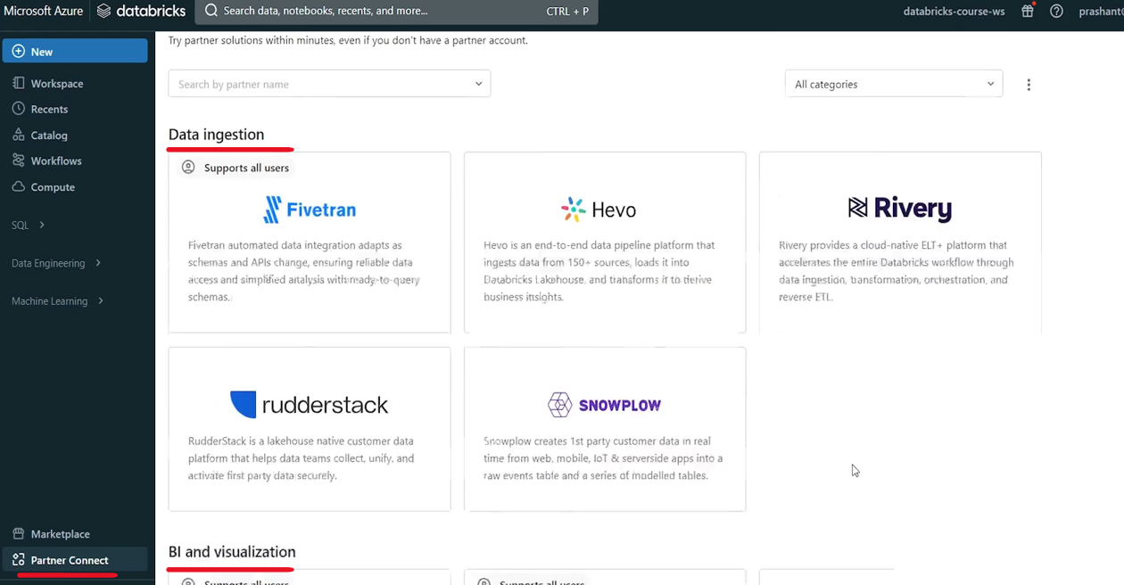

These are the partners for data preparation and transformation. These are the partners. These are machine learning partners the security partners data governance. So these are basically other partner vendors who are offering different kind of, solutions which you might need for your Lakehouse implementation or for your data engineering project. if you need them, you can directly integrate it from the Partner Connect page. they offer easy integration with the Databricks platform. So that's all about the left side, menu bar. This is how Databricks workspace is organized. you also have a menu here at the top right corner. If you expand this, you will see these menu items, user settings, admin settings.

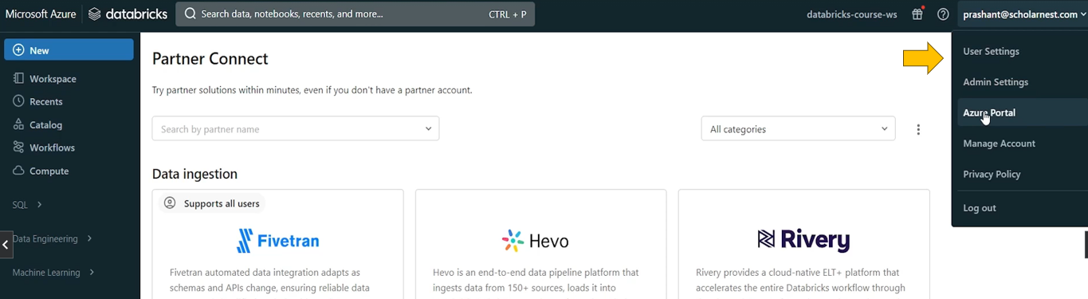

Yet this should take you back to your Azure Portal. Manage account will take you to Databricks Admin Console. And this is a Privacy Policy link. And you can log out from here. So we will time to time go to on these menus as and when needed and keep on learning what is there in the user settings, in admin settings or in account console or manage account. But for now, you should know that the there is a menu here. So that's it all about the Databricks Workspace UI. I just tried to give you a walkthrough of the UI. And so you are familiar with what is where and how to use these items, what functionality they offer that we will keep on learning throughout the course as we progress with the course. That's all for this lecture. See you again. Keep learning and keep growing.

## Azure Modern Analytics Architecture

<https://learn.microsoft.com/en-us/azure/architecture/solution-ideas/articles/azure-databricks-modern-analytics-architecture>

## Medallion Architecture

<https://www.databricks.com/glossary/medallion-architecture>

## Databricks Documentation

<https://learn.microsoft.com/en-us/azure/databricks/>

## Databricks Platform Architecture



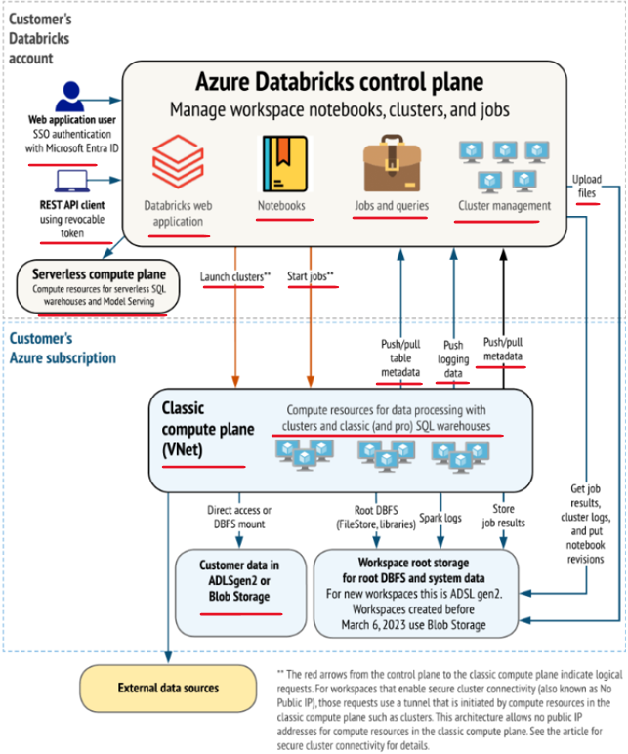

When we created our Databricks workspace in the Azure cloud I mentioned that Databricks Workspace is a serverless application running somewhere in the cloud. And we can access that serverless application through the web UI, through a URL. And I showed you that URL. So what is Databricks Workspace. And Databricks Workspace is a serverless application running in the Azure cloud. And we access it through the web UI. But how? It is architected and how other things are architected for a Databricks workspace in the Azure cloud. Let's try to understand the Databricks workspace architecture, the layout in the Azure cloud. So this diagram represents the same. You can see we have one box here which represents the **Azure Databricks Control plane**. So control plane is basically the Databricks software the Serverless Application. So when we create a workspace Azure will create a Databricks or **Azure Databricks Control Plane**. It's a **Serverless Application**.

Within that control plane. There are many things like your Databricks web application and Databricks web application is running, in the control plane. And we access that web application using the Databricks Workspace UI, in the browser tab. And within the Databricks workspace, we can create notebooks. We create notebooks, which are, created in the workspace itself. I'm not talking about notebooks in the repos. I'm talking about the notebooks in the workspace. So those notebooks also sit inside the Databricks control plane. We saw in the Databricks workspace, we have, menu item for workflows where we can create different kinds of jobs. So all those job configurations, queries, alerts, whatever, objects we are creating in the Databricks workspace, all those configurations are also stored in the control plane. And we also saw a cluster menu. We can create Databricks, clusters. So all those cluster configurations how to create cluster. What kind of cluster do we want to create. All those cluster configurations are also stored in the Databricks Control Plane. The idea is that the Databricks application is a serverless application which runs in a **Virtual Control Plane in the Azure cloud**, which is basically a **web based application offered to us through the Databricks Web UI** and all the data that we create, basically configuration data like notebook job and queries, configurations, workflows, cluster creation configurations, all those configurations, all those configuration data is also stored in the control plane.

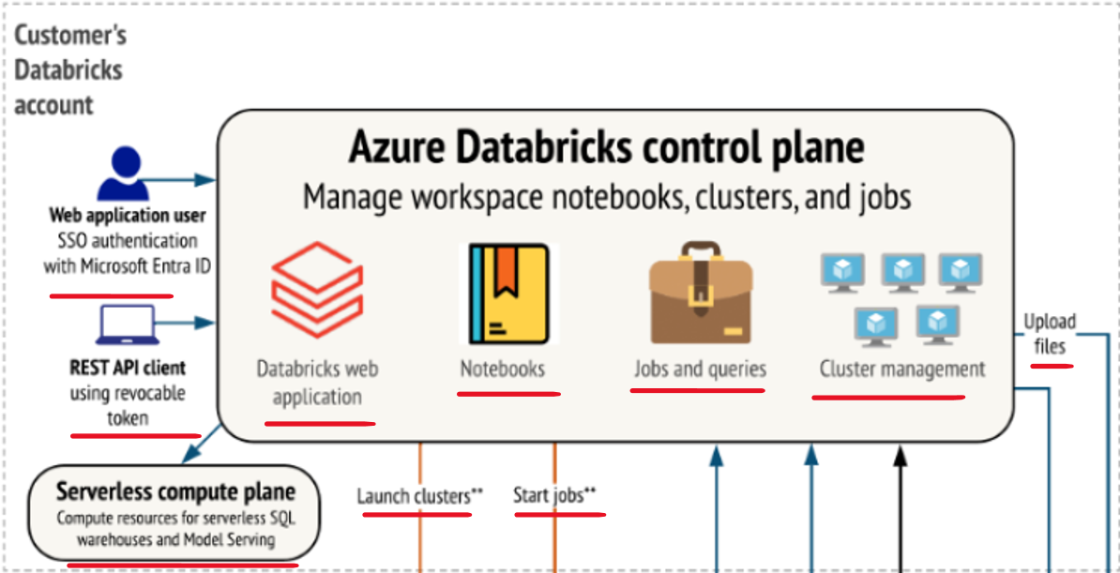

We do not have, direct access to the control plane from the back end or from anywhere, else except the web UI. We can access the control plane through the web UI, and that's what, this item represents here. A user is sitting outside the control plane, and they can access the control plane or the functionality offered by the control plane using the web based UI. And the credential verification and all that is implemented through single sign on. We can also access the control plane or functionalities from the control plane using the, Rest based API clients or command line tools. So those things are also possible. we will be sitting outside the control plane and access the control plane functionality. Basically workspace notebooks, cluster configurations, job configurations, all we can access through the Rest based APIs. So that's how the control plane is designed. but when we create cluster in the, using the Databricks workspace, those clusters are the physical or virtual machines. We as a customer need to pay for those virtual machines to Azure Cloud. So those cluster virtual machines are created in our Azure subscription or customers Azure subscription. And that space is known as customers Azure subscription or it is known as **Data Plane**. So this portion is known as data plane.

And this portion is known as control plane. So control plane is created for Databricks. but data plane or everything shown here is created in our Azure subscription. So when you create clusters you will be using virtual machines. Those virtual machines are created in your. Azure subscription. You can see those virtual machines. You can log in to those virtual machines. You can terminate those virtual machines. You have access to the virtual machines because it is created in your, Azure account. Now, next thing is about the data. for your, data engineering projects, you will be creating data. You will be collecting data, you will be creating intermediate data. You will be creating results data. So where will you store that data? For data you can create, storage layer. So when we create Databricks for the first time by default it will create one in the Azure it will create one default storage layer which is **workspace root storage** or **root Dbfs**. And Dbfs is Databricks File System ( see bottom right of above diagram ).

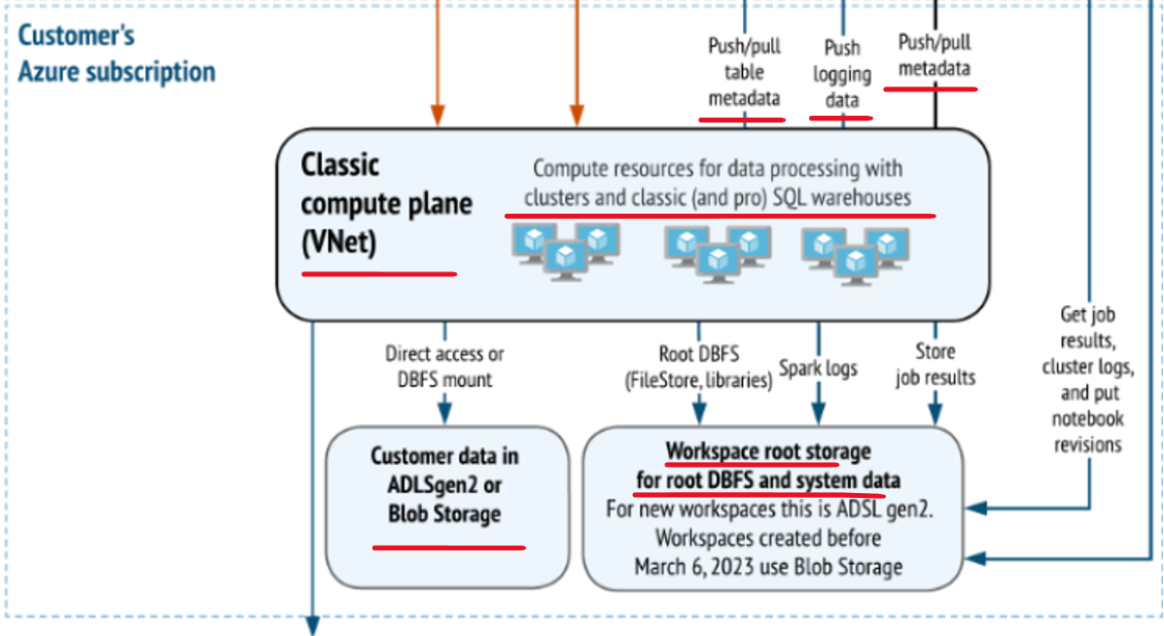

When you create a workspace. Every workspace in the Azure cloud comes with one default root account, or root storage layer, which is Dbfs root storage layer for your. Workspace and that is created in your. data plane in your customers, Azure subscription, you can see that you might not be able to access that easily because it is secured by workspace. by Databricks workspace. To access this route storage, you have to come to the Databricks workspace, and you can access it from the Databricks workspace itself. But if you try to access it directly from your cloud account or from your Azure account, you might face different kind of difficulties, and you are not supposed to access it from directly from your, cloud account. but this is not the storage layer which we should be using for, storing our data. For the data lake or for the lake house or whatever data we want to ingest in our platform for doing the data processing. This is not the place where you should be ingesting your data as a best practice. See the left side of bottom ( ADLSgen2 or Blob Storage )

In a typical case, we create a separate storage account and that's known as your data storage account or data storage layer. So in most of the projects we will create a separate storage layer in our Azure subscription so that we have a full control of it. And we keep data in our own custody, and we secure it in the way we want to secure it. So that's how the architecture is. The main point that we should understand and take away is that Databricks work space is deployed in. Two planes. The first plane is known as Control plane, which is in full control of Databricks itself. We cannot directly access it. The control plane or things in the control plane. The only way to access things in the control plane is through the UI or through the Rest APIs. Everything else is created in the data plane, and data plane is in our Azure subscription. We are in full control and we have to pay for it also. Everything else means mainly clusters, which is compute infrastructure and data storage layer, which is our storage layer. We will learn how to create clusters. We will learn how to use this root storage layer, how to use or create our own data storage layer, all that we will learn.

|  |  |
| --- | --- |
|  | All we want to understand is, clusters and data are always in the data plane in the customers, Azure subscription, Databricks workspace and all the configurations are in control plane  Databricks workspace is your goto place for doing your spark development or data engineering project development. But for doing project development, you need a couple of things. The first thing is you need a spark cluster because for executing your code, for testing your code, for running your code, you need a spark cluster, because a spark code runs only on the spark cluster. And you also need a development IDE. In Databricks Workspace, the development IDE is the notebook the notebook environment. So you will need these two things for doing your day to day project development activity. |

We will see how to create a spark cluster in Databricks workspace so that you can run your code on the spark cluster. Next thing we will try to learn how to work with the Databricks notebooks in the workspace environment. We will explore different features of the notebook and how to work with the notebooks. To simplify your day to day development activity and to solve some common problems, notebook environment offers you two types of additional capabilities. The first one is known as notebook Magic commands. So in the following lecture we will learn about the notebook magic commands. And then Databricks also offers some utilities as a package. So we will also learn Databricks Utilities package and learn things that you can do using utilities packages and magic commands.

## Azure Databricks Cluster

Go to your Databricks workspace. We want to create a new Databricks cluster.

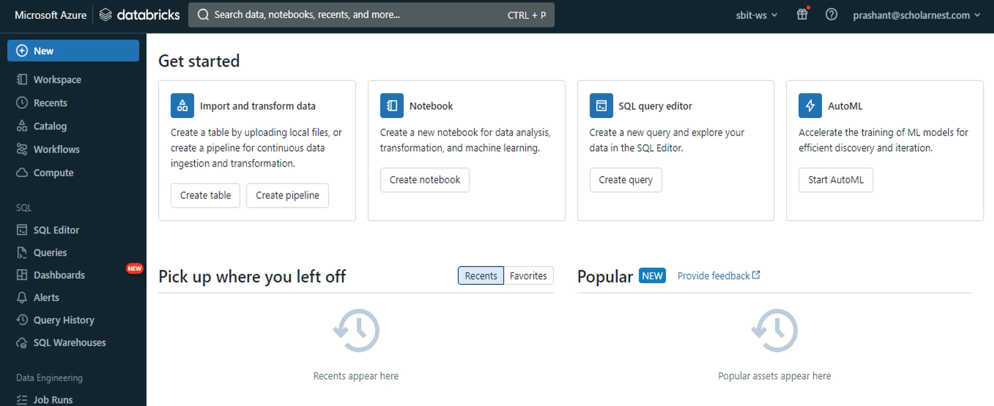

You can also create job clusters, SQL warehouse, and we also have an option to create a cluster pool. You can also create cluster security and access policies. Let's hit the Create Cluster button and create an all purpose cluster. The first thing is to give a name to this cluster.

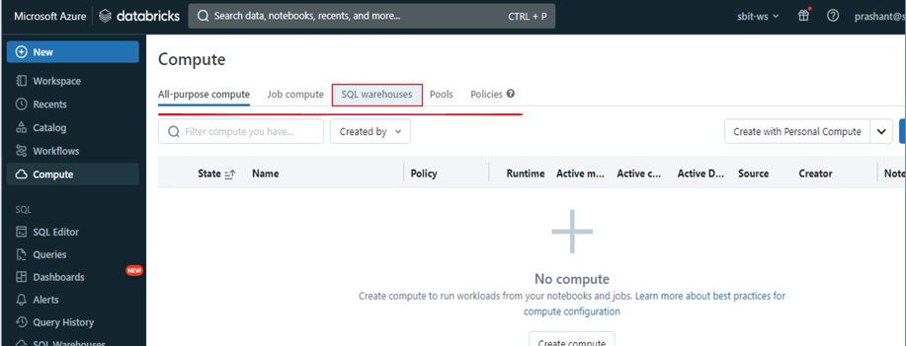

Let me change the name of this to demo-cluster. The next step is to choose the cluster type. You can create a multi-node cluster or a single node cluster. A multi node cluster will start the driver and executors on separate machines. The single node cluster will start on a single machine and your driver and executors will run on the same machine.

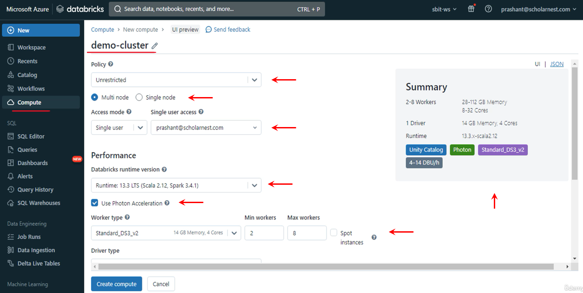

Access Mode has 3 options – Single User, Shared, No Isolation Shared – we will cover these options later.

Go with the default runtime, because that is the latest with good support

|  |  |
| --- | --- |
|  | We have three options single user shared and no isolation shared. Let's go with the single user and I'll cover the three types later. The next option is to choose your Databricks runtime. You can go with the default runtime because that's the latest with long time support. You can also choose photon acceleration. The photon is a new accelerated query engine for spark, and it is designed to boost your query performance. It comes with some extra cost. We do not need it for learning purpose, so let me remove it.  The next option is to choose the worker node type. Your default selection might be higher and more expensive, so make sure you are choosing this appropriately. The minimum VM size is 14 GB of memory and four CPU cores, so for learning purposes choose the 14 GB and four CPU core VM. But remember this one is a VM configuration for each worker.  If you are running two workers, you will have eight cores and 28 GB of memory at the worker end, right? The next option is to choose minimum and maximum number of workers. |

And these two options are related to auto scaling. You can see the enable Auto Scaling option here. This option is enabled by default. So what is auto scaling. Well you can define the minimum and maximum number of workers. The default setting is two minimum and eight maximum. You can change to whatever you want. I can even set it to a minimum of one and a maximum of two.

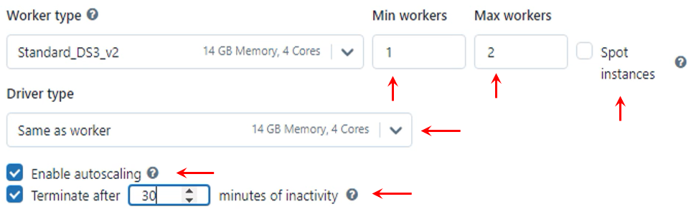

So when I start the cluster, it should start with one worker. And depending upon the workload, Databricks will automatically increase it to two workers. I won't go beyond two workers because that's the maximum. Similarly, it will automatically terminate one worker when the workload comes down and reduce it to a single worker. So auto scaling will automatically scale up and down your cluster size depending on the workload.

You can also switch on the auto terminate option. It is enabled by default. Databricks will terminate this cluster if my cluster is idle for one 20 minutes. I can change this value to ten minutes or anything above ten minutes. Let me set it to 30 minutes. That's an ideal and recommended setting for learning clusters. You must set an auto termination to your clusters to protect against unnecessary costs. You can restart it again even if it is terminated. The next option is to choose the driver VM. You can make it the same as worker or choose a different VM size. I am choosing the same size because that's the bare minimum I can get, and the bare minimum is more than enough for learning projects.

You can add some custom tags to your cluster. Some tags are automatically created. The tags are user defined metadata about the cluster. You can use these tags to identify them in a various reports. We also have some advanced options.